Specification for the National Medicines Optimisation Opportunities Dashboard

Contents
1. Background 2
2. Purpose 2
3. General technical notes 2
4. Primary care prescribing metrics – general notes 2
5. Secondary care prescribing metrics – general notes 3
6. Approach to ranking organisations in terms of high and low opportunities 3
7. Selecting peer groups for comparison 4
8. Thresholds for highlighting high and low opportunity organisations 5
9. Metric Specifications 6
Metric 01.Problematic polypharmacy 7
Metric 02.Low priority prescribing 8
Metric 04.Secondary care commercial framework 9
Metric 06. Best value biologics - ranibizumab 10
Metric 08.Prescribing of blood glucose, ketone meters, and testing strips 12
Metric 09. Best value direct-acting oral anticoagulants 14
Metric 11.Carbon emissions from inhalers 16
Metric 12.Valproate safety 17
Metric 14.Course length of antimicrobial prescribing 18
Metric 15.Opioid use 19
Metric 16.IV antibiotics to oral 21
Appendix 1: Medicine group details 22
Appendix 2: Governance and support 23

Background
The national medicines optimisation opportunities dashboard has been developed with NHS England to bring together data to support the national medicines optimisation opportunities 2023/24. It includes a collation of the headline metrics that have been selected to support the opportunity areas described in the guidance. Metrics for any remaining opportunities will be added when they have been developed and agreed by NHS England.
This specification is a technical document including details on the calculation of each metric included in the dashboard and other supporting information.

Purpose
This dashboard aims to offer a streamlined solution to monitoring multiple opportunities, so that the position across the different areas can be seen in only one place. For each opportunity, it is possible to track progress, compare against peers, and identify good practice or scope for improvement. The headline metrics in this dashboard reflect the policy framework and aim to shed light on multiple areas of improvement, spanning aspects such as value for money, patient safety, quality, and environmental benefits.
This dashboard signposts to more detailed dashboards or products for each opportunity area and does not intend to offer a comprehensive, detailed view of each of the opportunities. Once opportunities are selected by systems, it is intended that this product is used in combination with more detailed reports and information about the chosen opportunities. Supporting materials and additional links to data sources for all opportunities can be found in the following publication.

General technical notes
Data has been presented at the level of England (National), Region and Integrated Care Board (ICB) An additional view showing the lowest level organisations within each ICBs for which the metric is available. Normally this lowest level view will be:
- GP Practice or Primary Care Prescribing Cost Centre for primary care metrics,
- NHS trust for secondary care metrics.
Most of the metrics are available in more detail in other platforms or products, and the calculation follows these other sources as closely as possible. This may mean that metrics tend to focus on either primary or secondary care settings and do not necessarily cover both settings. For example, ePACT2 dashboards based on GP Practice Prescribing would typically exclude any prescriptions dispensed in community pharmacies that had been prescribed by Prescribing Cost Centres linked to NHS Trusts. The detailed specification for each metric given here will highlight any such exclusions.

Primary care prescribing metrics – general notes
All data is based on prescriptions from English prescribing organisations that were submitted to the NHSBSA for processing.
English prescribing that has been dispensed in Wales, Scotland, Guernsey / Alderney, Jersey and Isle of Man is also included – however, these items may be effectively excluded from the comparators that include only prescriptions items for which a patient could be identified.
All data excludes:
- Items not dispensed, disallowed and those returned to the contractor for further clarification.
- Prescriptions prescribed and dispensed in Prisons, Hospitals and Private prescriptions.
- Items prescribed but not presented for dispensing or not submitted to NHS Prescription Services by the dispenser
Medicine groups are based on the British National Formulary (BNF) classification system prior to BNF edition 70. This also includes pseudo-BNF codes assigned to appliances and several annual updates made by NHSBSA. A mapping document showing how these BNF codes map to SNOMED codes can be found on the NHSBSA website – ‘BNF to SNOMED Mapping Document’.
More information on annual updates can be found on the NHSBSA website – for example: ‘BNF Code Changes January 2022’.
The specific BNF Chapters, Sections, Paragraphs used for each metric are given below or in other specifications referred to below. Note that BNF classifications are based on a primary therapeutic area for a product and do not necessarily reflect the specific indication for a prescription.

Secondary care prescribing metrics – general notes
For the purpose of bringing all opportunities data together, this product features some secondary data care data which is licensed but not owned by NHSBSA. Secondary care data is collected, collated and standardised by Rx-info. The data is derived from multiple hospital sources (in-patient pharmacy system, homecare, FP10HNC, third-party out-patient provider, etc.) and results into a reportable dataset. NHSBSA receive bespoke data extracts which are then ingested into ePACT2.
Specifically, data within this dashboard is pulled from two of the Rx-info packages, Define and Exend+. These packages derive from Trusts allowing data sharing within the NHS through national license agreements. Define has been designed to gather issues data about medicines used in hospitals and benchmark their use against others in a cohort. Exend+ monitors contract tendering and NHS contract adherence performance, through contract variance reporting.

To prevent the disclosure of commercially confidential information at NHS Trust level, some information may be supressed (e.g., numerators and denominators behind the metric displaying the % of contract variance).
A few Trusts have missing data for this metric due to pharmacy stock control system integration issues with Exend+. Work is ongoing to remediate this.
A few Trusts might have small negative values (due to medicines returns) or other inconsistent data points in some months, these might be removed or suppressed to keep the metric within the expected range. These issues are noted in the supporting information for the relevant metrics.
Rx-info uses current ODS portal published codes and has merged organisations in accordance with current NHS structure. For historic data, Rx-info Define data extracts use the historic trust codes, for some of the metrics these have been mapped onto new trust.
Data is revised in Rx-info, with the monthly updates reflecting the snapshot at the time of update. Each month, the time series is updated with the most recent data at the time of update. Extraction timings can explain discrepancies between the dashboard and data extracted directly from Rx-info at a different point in time. Data is collated on a daily basis and backtracking of issues and purchases will take place in Define and Exend+.

Approach to ranking organisations in terms of high and low opportunities
The Region and ICB pages offer a ranked view across all opportunities, this ranks organisations for each opportunity according to the value of their headline metric on a given period. Organisations or geographies are ranked according to the improvement direction of each metric – this can be found in the table below.
For example:
- For Problematic Polypharmacy (Lower) a rank of 1 represents the highest metric value, and therefore the greatest scope for improvement. Higher ranks represent a lower scope for improvement.
- For Reducing course length of antimicrobial prescribing (Higher) a rank of 1 represents the lowest metric value, and therefore the greatest scope for improvement. Higher ranks represent a lower scope for improvement.
The ranked view can provide a relative view of which opportunities have the highest scope of improvement in relation to other organisations. The metric value view can show the absolute value and the size of differences between organisations.
Note that we do not expect this to be read in isolation. In some instances, it will be relevant to compare the trend of a specific organisation to assess the trajectory of the metric for an opportunity, or to compare a selected organisation or geography to similar peers – see the next section for more information.
Opportunity | Headline metric | Improvement direction
Addressing problematic polypharmacy | Percentage of patients aged 75 and over on 10 or more unique medicines | Lower
Improving valproate safety | Number of female patients prescribed valproate per 1,000 population | Lower
Addressing low priority prescribing | Total cost per 1,000 registered patients for NHS England low priority treatments | Lower
Appropriate prescribing and supply of blood glucose and ketone meters, and testing strips | Percentage of spend on recommended blood glucose and ketone testing strips for 12-month rolling period | Higher
Improving respiratory outcomes while reducing the carbon emissions from inhalers | Greenhouse gas emissions (kgCO2e) from inhalers per patient | Lower
Reducing course length of antimicrobial prescribing | Percentage of shorter (5-day) antibiotic courses | Higher
Switching intravenous antibiotics to oral | Proportion of total antibiotic treatment days administered intravenously | Lower
Obtaining secondary care medicines in line with NHS England commercial medicines framework agreements | Contract variance as a percentage of total spend | Lower
Reducing opioid use in chronic non-cancer pain | Patients aged 18+ currently prescribed an oral or transdermal opioid for more than three months per 1,000 patients in GP list | Lower
Patients using best value direct-acting oral anticoagulants | Percentage of direct-acting oral anticoagulant prescription items that were generic apixaban | Higher
Using best value biologic medicines in line with NHS England commissioning recommendations | Biosimilar share of ranibizumab singles | Higher

Selecting peer groups for comparison
The dashboard offers an ICB Comparison view that enable analysis of many comparators across many ICBs together. On this page there are prompts that enable the user to choose a set of ICBs and Comparators.
Any set of ICBs can be selected but a User may prefer to select ICB from their region, or to consult information on “similar 10” organisations based on information available in the NHS RightCare Methods Toolbox in FutureNHS.

Users who have selected a preferred peer group may find the ePACT2 “Save Current Customisation” option useful so they can easily return to previously selected groups. This can be after selecting the preferred ICBs and Metrics by using the “Gear” icon towards the top right-hand corner of the ePACT2 screen.
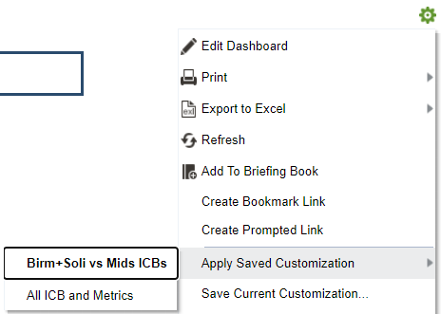

Thresholds for highlighting high and low opportunity organisations
Some of the dashboard sections show the number of organisations with “high” or “low” scope for improvement. This is based on a distribution of lower-level organisations nationally and depends on the set threshold which users can personalise.
For the example of addressing problematic polypharmacy, with a chosen threshold of 20%:
The organisations classed as “high scope for improvement” will be those on the top 20% of the national distribution of the percentage of patients aged 75 and over on 10 or more unique medicines, across all practices in England.
Note that as the thresholds are set based on the national distribution of trusts or primary care prescribing cost centres it is possible for an ICB to have no sub-organisations above the upper or below the lower level.
The ICB Organisations page demonstrates this distribution and the classification of the low level organisations within the selected ICB.
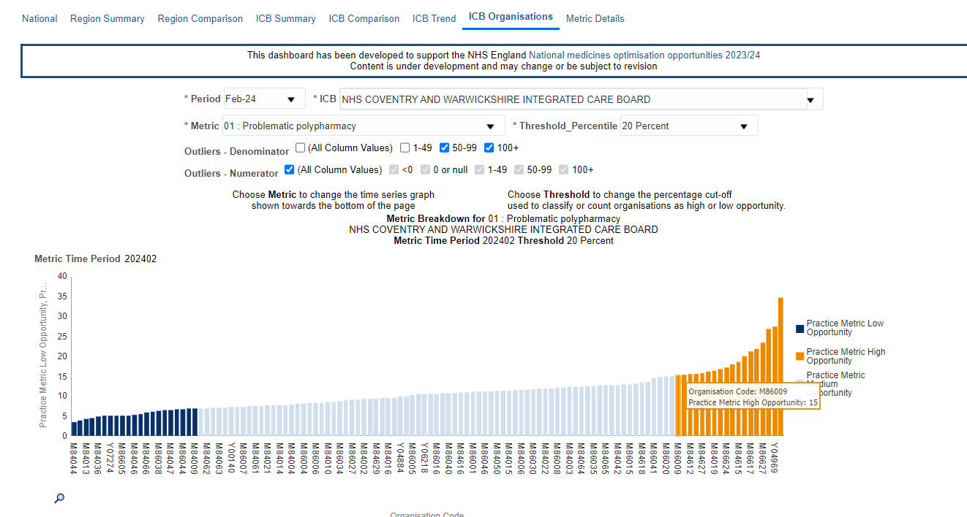
Choosing a lower Threshold Percentile will highlight practices that are further towards the top or bottom of the distribution. For example, choosing 5% for this metric highlights a smaller number of practices.
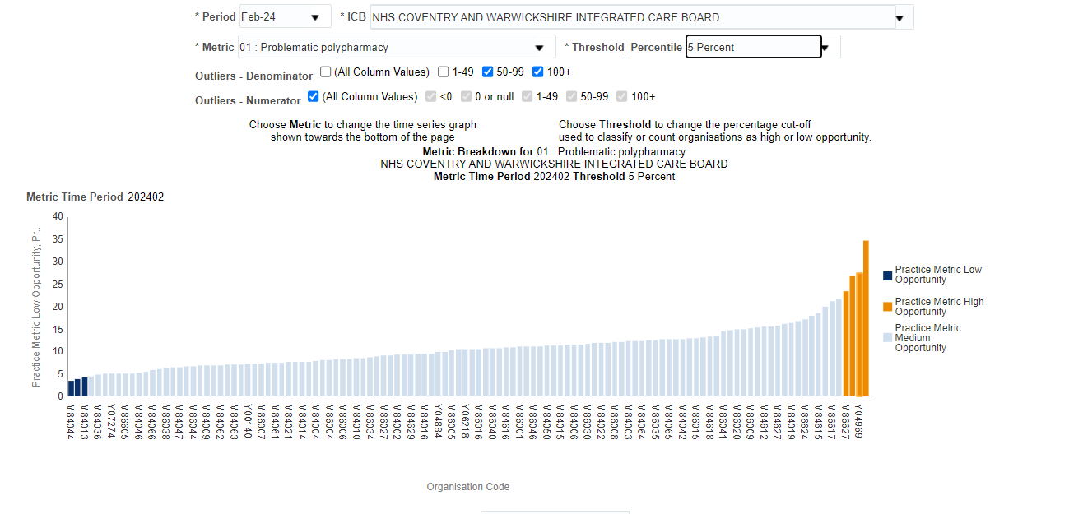
For the example of appropriate prescribing and supply of blood glucose and ketone meters, and testing strips, with a threshold of 25%:
The organisations classed as “high scope for improvement” will be those on the top 25% of the national distribution of the percentage of spend on recommended blood glucose and ketone testing strips, across all Practices in England.
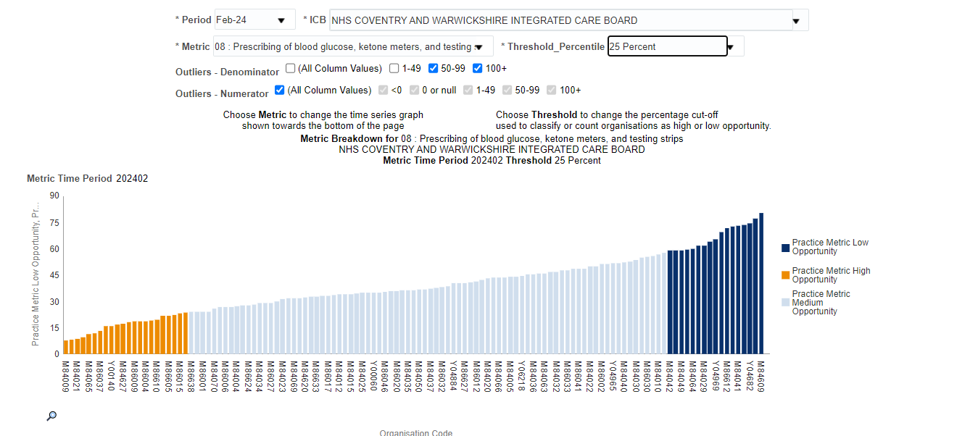
Secondary care measures are more sensitive to the selection of the threshold percentile as these are typically reported at the level of NHS Trusts meaning there are fewer organisations nationally, and fewer within each ICB that for GP Practices. Any missing data for a Trust can skew the position for an ICB quite significantly.

Metric Specifications
Please note as new metrics are developed and added to the dashboard more information may be added here. Metrics are ordered and given a number that matches the National medicines optimisation opportunities 2023/24 guidance document. Where a headline metric is not available, there may be gaps in the sequence of numbers.

Metric 01.Problematic polypharmacy
Opportunity title | Problematic polypharmacy
Opportunity description | Addressing problematic polypharmacy
Metric type | Primary care
Metric description | Percentage of patients aged 75 and over on 10 or more unique medicines
Is Higher or lower "better"? | Lower
Numerator | Number of patients aged 75 or over prescribed 10 or more unique medicines from BNF Chapters 1-4,6-10 in a single month
Numerator unit of measure | Patients
Denominator | Total number of patients aged 75 and over, prescribed one or more  medicines within BNF chapters 1 to 4 and 6 to 10 during same time period
Denominator unit of measure | Patients
Hyperlinks to supporting information | NHSBSA - Polypharmacy Prescribing Comparators - Summary webpage
 | Health Innovation Wessex - Polypharmacy Overview
Notes | Includes items prescribed by English GP Practices with 'active' status.
 | Patients may appear in the numerator or denominator for multiple organisations, and in many months.
 | Unique medicines are defined as the count of unique BNF Chemical substances dispensed for the patient in the reporting month.
Medicine Group Definitions | All BNF Chemical Substances that are mapped to the following BNF Chapters are included.  BNF Chapter Code BNF Chapter  01 Gastro-Intestinal System  02 Cardiovascular System  03 Respiratory System  04 Central Nervous System  06 Endocrine System  07 Obstetrics, Gyn. and Urinary Tract Disorders  08 Malignant Disease and Immunosuppression  09 Nutrition And Blood  10 Musculoskeletal and Joint Diseases
Other inclusion or exclusion criteria: | Includes active English GP Practices only

Metric 02.Low priority prescribing
Opportunity title | Low priority prescribing
Opportunity description | Addressing low priority prescribing
Metric type | Primary care
Metric description | Total actual cost per 1,000 registered patients for NHS England low priority treatments
Is Higher or lower "better"? | Lower
Numerator | Total Actual Cost of all items in the medicines value programme items which should not be routinely prescribed in primary care
Numerator unit of measure | Actual Cost GBP
Denominator | Total number of registered patients
Denominator unit of measure | Patients
Hyperlinks to supporting information | NHS England - Items which should not be routinely prescribed in primary care
 | NHSBSA - Items which should not be routinely prescribed in primary care - Summary webpage
 | OpenPrescribing - Items which should not routinely be prescribed in primary care
Notes | Does not include the costs of prescribing of over the counter items which should not be routinely prescribed in primary care. See ePACT2 'Over the counter' dashboard for further details.
Medicine Group Definitions | All medicines included in the ePACT2 dashboard ‘Items not for routine prescribing – see the Supporting Information page Drug Classifications section for the detailed list.  Alternatively, medication groups can be found in the following guidance: NHS England » Items which should not routinely be prescribed in primary care: policy guidance
Other inclusion or exclusion criteria: | Includes active English GP Practices with list size of 1 or greater

Metric 04.Secondary care commercial framework
Opportunity title | Secondary care commercial framework
Opportunity description | Obtaining secondary care medicines in line with NHS England commercial medicines framework agreements
Metric type | Secondary care
Metric description | Percentage difference between contract price as per framework agreements and actual price paid as a percentage of total spend in secondary care medicines
Is Higher or lower "better"? | Lower
Numerator | Total difference between price paid and price established in the commercial framework. Note only the metric data is visible to users, numerator is hidden due to commercial sensitivities.
Numerator unit of measure | GBP
Denominator | Total spend in secondary care medicines. Note only the metric data is visible to users, denominator is hidden due to commercial sensitivities.
Denominator unit of measure | GBP
Hyperlinks to supporting information | RX-info - Exend+ data
 | NHS England - Medicines Efficiencies - FutureNHS Collaboration Platform
Notes | RX-info data may be subject to revision.  This metric only includes Trusts for which the contract variance information is available.
 | Some Trusts have missing data for this metric due to integration issues with Exend+.
Medicine Group Definitions
Other inclusion or exclusion criteria:

Metric 06. Best value biologics - ranibizumab
Opportunity title | Best value biologics - ranibizumab
Opportunity description | Using best value biologic medicines in line with NHS England commissioning recommendations
Metric type | Secondary care
Metric description | Biosimilar share of ranibizumab singles
Is Higher or lower "better"? | Higher
Numerator | Quantity of ranibizumab biosimilar singles issued
Numerator unit of measure | Number of singles
Denominator | Quantity of ranibizumab originator or biosimilar singles issued
Denominator unit of measure | Number of singles
Hyperlinks to supporting information | NHS England - Updated commissioning recommendations following the national procurement for ranibizumab biosimilars
Notes | RX-info data may be subject to revision.  Some trusts are missing from this metric due to a lack of reliable data or inconsistent data points.  RX-info define data extracts use historic trust codes these have been mapped onto new trust codes where possible.
Continued overleaf
Medicine Group Definitions | Ranibizumab biosimilar, originator and other classifcation  VMP VMP AMP Category  1563 Ranibizumab 2.3mg/0.23ml solution for injection vials Ongavia 2.3mg/0.23ml solution for injection vials Biosimilar  1563 Ranibizumab 2.3mg/0.23ml solution for injection vials Lucentis 2.3mg/0.23ml solution for injection vials Originator  17431 Ranibizumab 1.65mg/0.165ml solution for injection pre-filled syringes Lucentis 1.65mg/0.165ml solution for injection pre-filled syringes Originator  16338 Aflibercept 4mg/100microlitres solution for injection vials Eylea 4mg/100microlitres solution for injection vials Other  21253 Aflibercept 3.6mg/90microlitres solution for injection pre-filled syringes Eylea 3.6mg/90microlitres solution for injection pre-filled syringes Other  21040 Brolucizumab 19.8mg/0.165ml solution for injection pre-filled syringes Beovu 19.8mg/0.165ml solution for injection pre-filled syringes Other  22432 Faricimab 28.8mg/0.24ml solution for injection vials Vabysmo 28.8mg/0.24ml solution for injection vials Other  1563 Ranibizumab 2.3mg/0.23ml solution for injection vials Ximluci 2.3mg/0.23ml solution for injection vials Biosimilar  1563 Ranibizumab 2.3mg/0.23ml solution for injection vials Byooviz 2.3mg/0.23ml solution for injection vials biosimilar  23700 Aflibercept 30.1mg/263microlitres solution for injection vials Eylea 30.1mg/263microlitres solution for injection vials other
Other inclusion or exclusion criteria:

Metric 08.Prescribing of blood glucose, ketone meters, and testing strips
Opportunity title | Prescribing of blood glucose, ketone meters, and testing strips
Opportunity description | Appropriate prescribing and supply of blood glucose and ketone meters, and testing strips
Metric type | Primary care
Metric description | Percentage of spend (NIC GBP) on recommended blood glucose and ketone testing strips prescribed out of spend (NIC GBP) on all blood glucose and ketone testing strips prescribed
Is Higher or lower "better"? | Higher
Numerator | Total Net Ingredient Cost (NIC GBP) for recommended blood glucose and ketone testing strips (12-month rolling)
Numerator unit of measure | Net Ingredient Cost (GBP)
Denominator | Total Net Ingredient Cost (NIC GBP) for all blood glucose and ketone testing strips (12-month rolling)
Denominator unit of measure | Net Ingredient Cost (GBP)
Hyperlinks to supporting information | NHS England - Commissioning recommendations following the national assessment of blood glucose and ketone meters, testing strips and lancets
 | Model Health System - Percentage of recommended blood glucose and ketone testing strips items prescribed out of all blood glucose and ketone testing strip items - Requires login
Notes
Medicine Group Definitions | All blood glucose and ketone testing strips (Denominator):  BNF Chemical Substance Code BNF Chemical Substance  0601060D0 Glucose blood testing reagents  0601060W0 Ketone blood testing reagents  0601060X0 Glucose and ketone blood testing reagents
Continued overleaf
Recommended blood glucose and ketone testing strips (Numerator):
BNF Presentation Code | BNF Presentation
0601060D0CIAAA0 | WaveSense JAZZ testing strips
0601060D0CIABA0 | WaveSense JAZZ Duo testing strips
0601060D0CUAAA0 | GlucoRx Q testing strips
0601060D0CUABA0 | GlucoRx Nexus testing strips
0601060D0CUACA0 | GlucoRx HCT Glucose testing strips
0601060D0EDAAA0 | Finetest Lite testing strips
0601060D0EHAAA0 | CareSens PRO testing strips
0601060D0EJAAA0 | True Metrix testing strips
0601060D0EKAAA0 | 4SURE testing strips
0601060D0ENAAA0 | Contour Plus testing strips
0601060D0EUAAA0 | On Call Extra testing strips
0601060D0EVAAA0 | GLUCOFIX TECH Sensor testing strips
0601060W0BEAAA0 | GlucoRx HCT Ketone testing strips
0601060W0BFAAA0 | KetoSens testing strips
0601060W0BGAAA0 | 4SURE beta-ketone testing strips
0601060X0BBAAA0 | KEYA Smart testing strips

Other inclusion or exclusion criteria: | Includes active English Primary Care Prescribing Cost Centres (linked to SICBLs)

Metric 09. Best value direct-acting oral anticoagulants
Opportunity title | Best value direct-acting oral anticoagulants
Opportunity description | Patients using best value direct-acting oral anticoagulants
Metric type | Primary care
Metric description | Percentage of direct-acting oral anticoagulant prescription items that were generic apixaban
Is Higher or lower "better"? | Higher
Numerator | Number of defined daily doses (DDD) of generic apixaban tablets and capsules dispensed in a rolling 3-month period
Numerator unit of measure | Defined Daily Doses (DDDs)
Denominator | Number of defined daily doses of edoxaban, rivaroxaban, dabigatran, or apixaban tablets and capsules dispensed in a rolling 3-month period
Denominator unit of measure | Defined Daily Doses (DDDs)
Hyperlinks to supporting information | NHS England - Commissioning recommendations for national procurement for direct-acting oral anticoagulant(s) (DOACs)
Notes | Includes a primary care prescribing cost centres mapped via SICBLs only, where currently listed as 'Active'
Medicine Group Definitions | All presentations including those prescribed by brand or with a named supplier within the following generic BNF codes are included.  BNF Generic Equivalent Presentation Code BNF Generic Equivalent Presentation  0208020AAAAAAAA Edoxaban 15mg tablets  0208020AAAAABAB Edoxaban 30mg tablets  0208020AAAAACAC Edoxaban 60mg tablets  0208020X0AAAAAA Dabigatran etexilate 75mg capsules  0208020X0AAABAB Dabigatran etexilate 110mg capsules  0208020X0AAACAC Dabigatran etexilate 150mg capsules  0208020Y0AAAAAA Rivaroxaban 10mg tablets  0208020Y0AAABAB Rivaroxaban 15mg tablets  0208020Y0AAACAC Rivaroxaban 20mg tablets  0208020Y0AAAEAE Rivaroxaban 15mg tablets and Rivaroxaban 20mg tablets  0208020Z0AAAAAA Apixaban 2.5mg tablets  0208020Z0AAABAB Apixaban 5mg tablets
Continued overleaf
The DDDs were calculated based on the following values:
BNF Chemical Substance plus Code | DDD Value (mg)
Edoxaban (0208020AA) | 60
Dabigatran etexilate (0208020X0) | 300
Rivaroxaban (0208020Y0) | 20
Apixaban (0208020Z0) | 10

Other inclusion or exclusion criteria: | Includes active English Primary Care Prescribing Cost Centres (linked to SICBLs)

Metric 11.Carbon emissions from inhalers
Opportunity title | Carbon emissions from inhalers
Opportunity description | Improving respiratory outcomes while reducing the carbon emissions from inhalers
Metric type | Primary care
Metric description | Greenhouse gas emissions (kgCO2e) from inhalers per patient
Is Higher or lower "better"? | Lower
Numerator | The volume of greenhouse gas emissions from inhalers (in kgCO2e) in a 3 month rolling period
Numerator unit of measure | kilogrammes of carbon dioxide equivalent (kgCO2e)
Denominator | Total number of patients prescribed one or more inhalers in a 3 month period. Each patient is counted once per month in which they were prescribed an inhaler.
Denominator unit of measure | Patients (patient months)
Hyperlinks to supporting information | Greener NHS Dashboard - Inhaler emissions - Requires login
 | OpenPrescribing - Environmental impact of inhalers
Notes | When exact emissions are not known average emissions values for inhalers based on device type and therapeutic group are used
 | Patients may appear in the denominator for multiple organisations
 | Figures may not match the more detailed Greener NHS metrics exactly due differences in the data source for national data, simplification in emissions factor assumptions and the treatment of practices and other types of prescribing organisation.
Medicine Group Definitions | See Appendix 1 for a description of the inhalers and GHG emissions factors used.
Other inclusion or exclusion criteria: | Includes a active English GP Practices and items with identified patients only

Metric 12.Valproate safety
Opportunity title | Valproate safety
Opportunity description | Improving valproate safety
Metric type | Primary care
Metric description | Female patients prescribed valproate per 1,000 population
Is Higher or lower "better"? | Lower
Numerator | Number of female patients in the age band 13-54 in the three-month period, who have been prescribed one or more items of a valproate product
Numerator unit of measure | Patients
Denominator | Number of female patients in the age band 13-54, who are registered with GP practices, in the same three-month period
Denominator unit of measure | List Size
Hyperlinks to supporting information | NHSBSA - Valproate safety dashboard - Summary webpage
 | NHS England - Medicines and Pregnancy Registry
Notes | This is a proxy metric as it does not fully reflect the safe prescribing of valproate, instead highlighting the extent of valproate prescribing. Please ensure that female patients taking valproate and with childbearing potential are participating in the Pregnancy Prevention Programme - please make use of your local data to investigate further.
Medicine Group Definitions | The detailed list of medicines and specification can be found here: NHSBSA - Valproate safety dashboard - Summary webpage  Medicines under the following chemical substances have been included in the indicators:  BNF Chemical Substance Code BNF Chemical Substance Name  0408010W0 Sodium Valproate  0402030Q0 Valproic acid  040801020 Valproic acid
Other inclusion or exclusion criteria: | Active English GP Practices.  Items with identified female patients aged 13 to 54 years old

Metric 14.Course length of antimicrobial prescribing
Opportunity title | Course length of antimicrobial prescribing
Opportunity description | Reducing course length of antimicrobial prescribing
Metric type | Primary care
Metric description | Percentage of shorter (5-day) antibiotic courses
Is Higher or lower "better"? | Higher
Numerator | Items of amoxicillin 500mg capsules prescribed as 15 capsules
Numerator unit of measure | Items at quantity = 15 capsules
Denominator | Items of amoxicillin 500mg capsules prescribed as any quantity
Denominator unit of measure | Items
Hyperlinks to supporting information | NICE - Antimicrobial stewardship
 | PrescQIPP - Antimicrobial Stewardship (AMS) Hub - Open access
Notes | Note figures are expected to be revised due a technical compromise for the initial release requiring the use of identified patient data only.
Medicine Group Definitions | Amoxicillin 500mg capsules - all medicines classified with generic BNF Presentation as 0501013B0AAABAB
Other inclusion or exclusion criteria: | Includes active English Primary Care Prescribing Cost Centres (linked to SICBLs) with identified patients only

Metric 15.Opioid use
Opportunity title | Opioid use
Opportunity description | Reducing opioid use in chronic non-cancer pain
Metric type | Primary care
Metric description | Patients aged 18+ currently prescribed an oral or transdermal opioid for more than three months per 1,000 patients in GP list
Is Higher or lower "better"? | Lower
Numerator | Patients aged 18+ prescribed an oral or transdermal opioid for each of the last four months
Numerator unit of measure | Patients
Denominator | Patients aged 18+ on GP list, four month average
Denominator unit of measure | Patients
Hyperlinks to supporting information | NHS England - Medicines Safety Improvement Programme
 | NHSBSA - Opioid Prescribing Comparators - Summary webpage
 | OpenPrescribing - Prescribing of opioids
Notes | Note this measure has been presented as a ratio per 1,000 GP list patients for comparative purposes. For patient safety purposes, the raw number of patients is also considered an important source of insight - see the "numerator" information within the detailed data tables, or other resources provided by the NHS England Medicines Safety Improvement Programme (MedSIP).  The aggregated GP list used for groups of GP Practices is based on the sum of four-month averaged list sizes. This may not be consistent with other measures of list sizes depending on the treatment of practices that open or close throughout the four-month period and the 'latest' practice used to report the patients in the numerator.
Continued overleaf
Medicine Group Definitions | See the NHSBSA ePACT2 medicines safety dashboard specification PAIN03 comparator for more details.  Oral or transdermal opioids are defined as:  Group BNF Description BNF Code  Oral medicines containing 15mg or more of codeine or 10mg or more of dihydrocodeine Non-Opioid Analgesics And Compound Prep (sub-set) 040701  Oral or transdermal opioids Opioid Analgesics (sub-set) 040702  A more detailed list of the sub-sets is included in Appendix 1.  Note this list may be periodically reviewed to pick up new brands or formulations but there may be a period of time between a brand entering the market and being added to the drug grouping used in the dashboard.
Other inclusion or exclusion criteria: | Includes English NHS prescriptions linked to identified patients for whom NHS BSA holds data for a registered GP practice only, aged 18 or over

Metric 16.IV antibiotics to oral
Opportunity title | IV antibiotics to oral
Opportunity description | Switching intravenous antibiotics to oral
Metric type | Secondary care
Metric description | Proportion of total antibiotic treatment days administered intravenously
Is Higher or lower "better"? | Lower
Numerator | Defined Daily Dose (DDD) count for dispensed intravenous antibiotic formulations
Numerator unit of measure | Defined Daily Doses (DDDs)
Denominator | Defined Daily Dose (DDD) count for total dispensed antibiotics (all formulations)
Denominator unit of measure | Defined Daily Doses (DDDs)
Hyperlinks to supporting information | Rx-info data series - Defined Daily Dose (DDD) count for dispensed intravenous antibiotic formulations
 | Rx-info data series - Defined Daily Dose (DDD) count for total dispensed antibiotics (all formulations)
Notes | These data are extracted using the filters that UKHSA use for all secondary care antibiotic metrics. Please be aware that these filters differ to those in the standard Rx-info define chart titled 'Antibacterial oral to IV ratio', primarily due to a difference in the prescription types included. Filters can be observed in the first two links above.
The figures produced in this indicator are raw and unadjusted for the confounding effects of both the age and sex mix of patient populations served by hospitals, or for other factors such as deprivation and complexity of care that can drive hospital antibiotic prescribing. Therefore, Trusts may appear outliers for this measure by fulfilling valid care of the specific population that they serve.
Further consideration is required to adapt antibiotic prescribing metrics for use in specialist healthcare settings, including an improved understanding of case-mix. However, until routine electronic prescribing of antibiotics is available nationally, there is limited work that can be performed in this area. For these reasons comparison between different organisations should be treated with caution. Nonetheless, as NHS national quality improvement schemes require each hospital to improve from its own baseline levels this is consistent with improving the quality of antibiotic prescribing in each hospital.
Medicine Group Definitions | Drugs are only included in the numerator if they have a British National Formulae (BNF) 5.1 code and Defined Daily Dose (DDD) values provided by the World Health Organization.
Other inclusion or exclusion criteria: | Anti-TB, Anti-Parasitic and topical antibiotics are excluded to align with requirements for the NHS Standard Contract and previous NHS England antibiotic resistance CQUINs.

Appendix 1: Medicine group details

Medicine group details for Metric 11.Carbon emissions from inhalers
Only products with a pharmaceutical form of: inhalation powder, inhalation solution, or, pressurised inhalation are included where they are included in the following BNF Chemical Substances:
BNF Chemical Substance Code | BNF Chemical Substance
0301011AB | Beclometdiprop/formoterol/glycopyrronium
0301011E0 | Formoterol fumarate
0301011F0 | Fenoterol hydrobromide
0301011R0 | Salbutamol
0301011U0 | Salmeterol
0301011V0 | Terbutaline sulphate
0301011X0 | Indacaterol maleate
0301011Z0 | Olodaterol
0301020I0 | Ipratropium bromide
0301020P0 | Oxitropium bromide
0301020Q0 | Tiotropium bromide
0301020R0 | Aclidinium bromide
0301020S0 | Glycopyrronium bromide
0301020T0 | Umeclidinium bromide
0301040AA | Glycopyrronium/formoterol
0301040M0 | Fenoterol hydrobromide
0301040R0 | Salbutamol
0301040V0 | Aclidinium bromide/formoterol
0301040W0 | Umeclidinium bromide/vilanterol
0301040X0 | Tiotropium bromide/olodaterol
0301040Y0 | Indacaterol/glycopyrronium
0302000C0 | Beclometasone dipropionate
0302000K0 | Budesonide
0302000N0 | Fluticasone propionate (Inhalation)
0302000R0 | Mometasone furoate
0302000U0 | Ciclesonide
0302000V0 | Fluticasone furoate/vilanterol
0302000W0 | Mometasone/glycopyrronium/indacaterol
0302000X0 | Indacaterol/mometasone
0302000Y0 | Formoterol/glycopyrronium/budesonide
0303010J0 | Nedocromil sodium
0303010Q0 | Sodium cromoglicate

One of the following six methods has been used to assign emissions factors to each type of inhaler:
- Based on NHSE Greener NHS Value (emissions factor available)
- Value for generic prescription items is based on a single brand for which estimates are available.
- Based on 17,335g CO2e assumption for MDI inhalers – average for all MDI inhalers for which an Emissions Factor was available
- Based on 730g CO2e assumption for DPI inhalers - average for all DPI inhalers for which an emissions factor was available
- Value for generic is based on midpoint for brands for which estimates are available, device type average was not within the range of the available estimates so was not considered plausible.
- No assumption applied; zero emissions included
The average emissions factors for each device type (MDI or DPI) are based on weighted averages of the number of inhalers prescribed by English GP Practices from April 2022 to March 2023. Weighted averages include only prescription items for which NHSE Greener NHS emissions factors were available.
The attached CSV file includes the emission factors that were ‘available’ (from NHSE Greener NHS assumptions) and those that were assumed along with an indication of which of the methods described above applies to each type of inhaler.

Medicine group details for Metric 15.Opioid use
See presentations flagged as PAIN03_FLAG = ‘Y’ for those included in the oral or transdermal opioids group. Other presentations from other common opioid groupings are also included for comparison.

Appendix 2: Governance and support
This dashboard is aligned with the following policy framework: NHS England » National medicines optimisation opportunities 2023/24, authored by the NHS England medicines policy and strategy unit. Questions about the opportunities or can be sent to england.medicines@nhs.net.
Queries regarding any technical aspects or support can be sent to DataServicesSupport@nhsbsa.nhs.uk.

This document was last updated 2024-05-08 and information may not reflect changes after that point.
This document will be reviewed and updated periodically.

