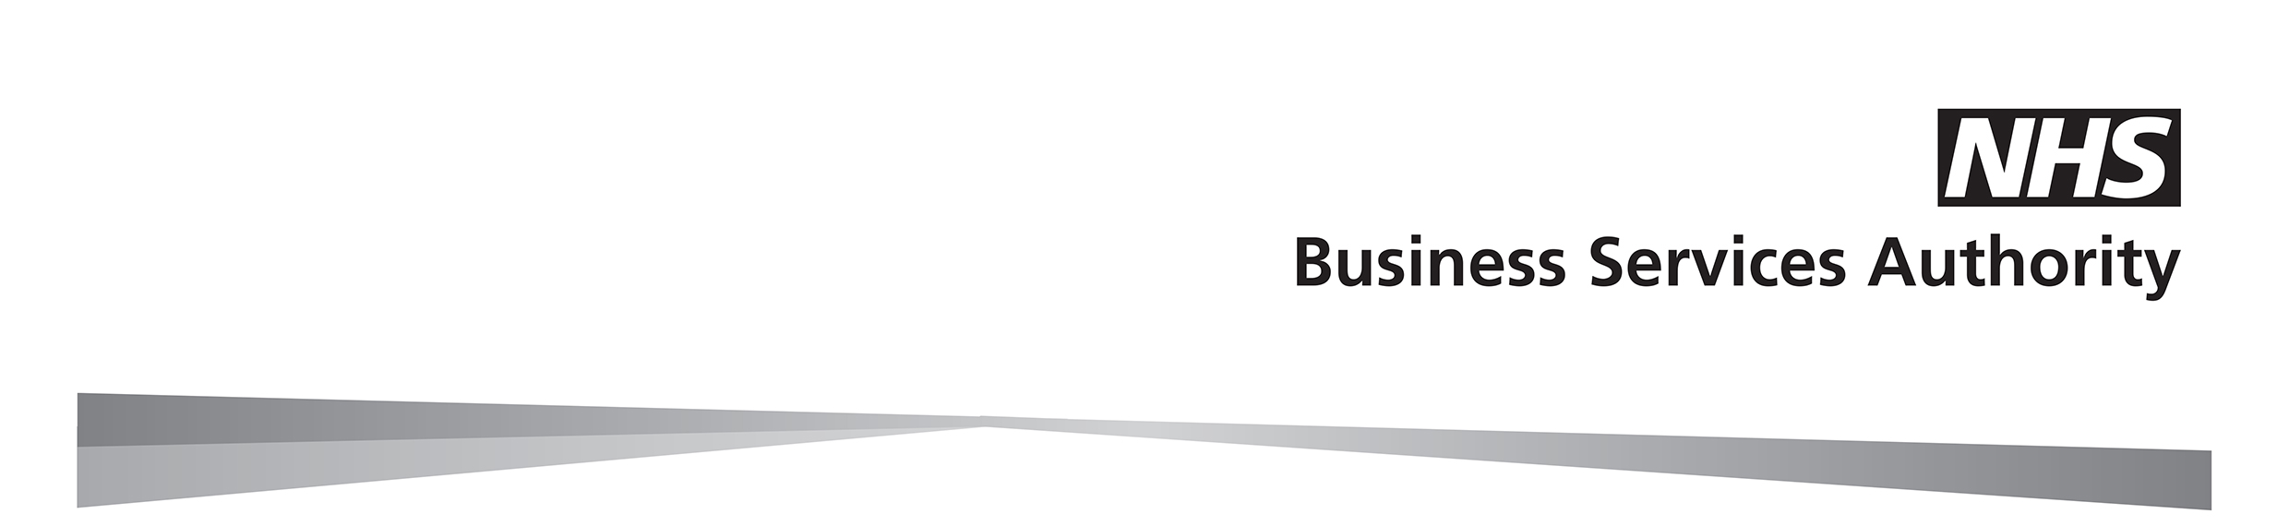
Early Retirement Reduction Buy Out (ERRBO) Expression of interest (2015 Scheme members only)

Before completing this form, please read the ERRBO factsheet which is available on our website at: www.nhsbsa.nhs.uk/nhs-pensions. Application form must be received between 1 April and 30 June or within three months of joining or transitioning to the 2015 Scheme

About you

Surname
First names
Address
National Insurance number
Membership number | SD |  |  |  |  |  |  |  | /
Date of birth |  |  |  |  | / |  |  |  |  |  |  |  |  | /
Name of employer
Start date of current employment |  |  |  |  |  |  |  |  |  | / |  |  |  |  |  |  |  |  |  |  | /

 | I have read the factsheet and applied within specified timescales. I believe I may be eligible to purchase an ERRBO. Please provide details of the cost and amount available to purchase.
Your signature
Date |  |  |  | / |  |  | /

Please send the completed form to NHS Pensions at:

NHS Pensions, PO Box 683, Unit 5, Newcastle Upon Tyne, NE5 9EE

How we use your information

The NHS Business Services Authority – NHS Pensions will use the information provided for administering your NHS Pension Scheme membership and processing payment of your NHS pension benefits. We may share your information to administer and pay your NHS pension, enable us to prevent and detect fraud and mistakes, for debt collection purposes, or as required by law. For more information about who we share your information with and how long we keep your personal data and your rights, please visit our website at www.nhsbsa.nhs.uk/yourinformation

