eDEN user guide
Finance Reports Guidance

Interactive Contents
Use this interactive contents list to jump straight to the content you want to see. Just click the titles below to go directly to that section:
Contents
About this document 4
General Notes 4
ICB level Finance Reports 5
ICB Finance 5
Finance 6
Region level Finance Reports 7
Finance 7
Items Description 9
ICB Finance reports 9
Regional Finance Reports 11
Getting more help 14

About this document
This document is designed to provide guidance around the different finance reports available within eDEN.
Finance reports are available at ICB and Regional level, depending on the access a user is registered with, and are included in the dashboards below.
- NHS England Dentistry Dashboard v1
- NHS England Central Dashboard

General Notes
Monthly payment data is extracted from CoMPASS and reported for each month of the financial year. Queries regarding the actual payments made should be sent to the Dental Finance team, who can be contacted via email on dentalfinance@nhsbsa.nhs.uk

ICB level Finance Reports
ICB level finance reports are available via the NHS England Dentistry Dashboard v1 dashboard. Reports are available for current ICBs and historical organisations.
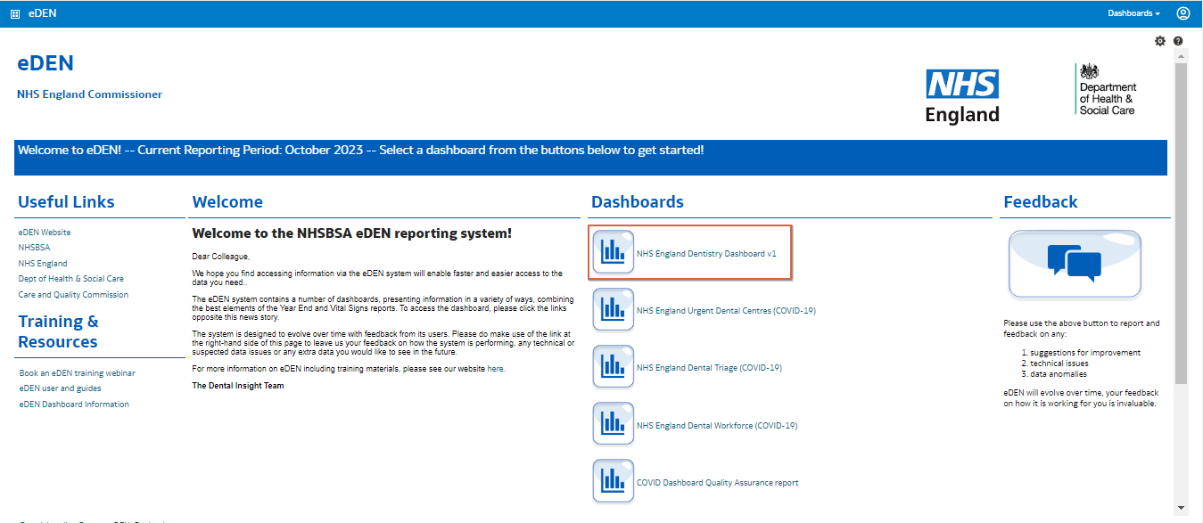

ICB Finance
Finance data shown using the ICB structure from April 2023, i.e., 2023-24 financial year onwards

Tabs

Country ICB Payments:
A selection of reports at national level showing payments monthly and for the financial year to date. In essence, this is the total cost of all contracts in England, with HEE and H&J costs excluded.
Downloads available – Region Payments data: (National Payments split by Region)

ICB Payments:
A selection of reports showing the payments monthly and for the financial year to date for the selected ICB. This is the total cost of all delegated items; therefore, this excludes H&J, HEE payments, and non-delegated performance adjustments. These are those performance adjustments relating to 2022/23 financial year or prior (with the exception of those ICBs in the South East Region and Greater Manchester ICB whereby 2022-23 performance adjustments are delegated).
Downloads available – Time Lag Report Current Month
All Contract Payment Report – current month and year to data
All Services data current year only

ICB Payments Breakdown:
A selection of reports showing the payments monthly and for the financial year to date for the selected ICB including a Payment Category and Payment Code, based on those payment categories and codes included on the ICB Payments tab

ICB Contract Payment:
Reports showing contract level payments monthly and for the financial year to date for the selected contract. These include all payments, both delegated and non-delegated, and so are the amounts actually paid to a dental contractor. These also match with the payment schedules, as issued by the NHSBSA to dental contractors via CoMPASS.

Finance
Finance data shown using the ICB structure for 2022/23 payments.

Tabs

Country and Region Payments:
A selection of reports at national level showing payments monthly and for the financial year to date.
Downloads available – Region Payments data: (National Payments split by Region)
Local Office Payments:
A selection of reports showing the payments monthly and for the financial year to date for the selected ICB.

Local Office Payments Breakdown:
A selection of reports showing the payments monthly and for the financial year to date for the selected ICB including a Payment Category and Payment Code.

Contract Payment:
Reports showing contract level payments monthly and for the financial year to date for the selected contract.

Region level Finance Reports
Region level finance reports are available via the NHS England Central Dashboard. Reports are available at national, regional and ICB level.

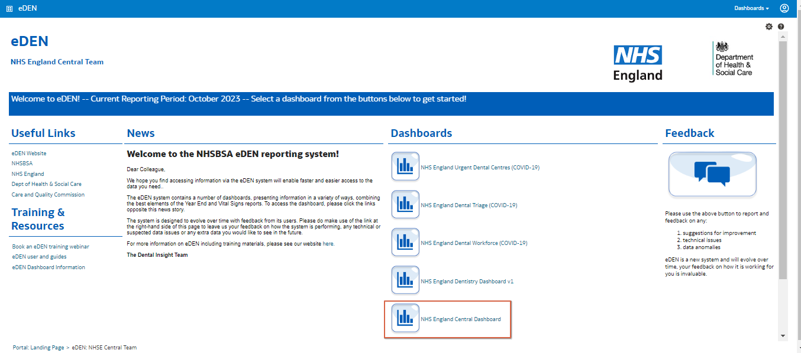

Finance
Finance data shown at national, regional and ICB level from April 2023.

Tabs

England Overall Payments:
A selection of reports at national level showing payments monthly and for the financial year to date. This is the total cost of all contracts, for both delegated and non-delegated payments.

Total ICB Payments:
A selection of reports showing the payments for ICBs monthly and for the financial year to date, this excludes any non-delegated costs including Health and Justice (H&J), Health Education England (HEE) related payments and Performance Adjustment Payments related to previous financial years e.g., 2021-22 and 2022-2. This report will only relate to costs delegated to the ICBs and will not include any of those cost attributed to the regions.

The “Performance Adjustments Delegated” line shown in this report relates to performance adjustment payments for the year 2023/24

Total Region ICB Payments:
A selection of reports for a selected region showing the costs attributed to the ICBs under that region, this report excludes any Health and Justice (H&J) and Health Education England (HEE) related payments but does include Performance Adjustment Payments related to previous financial years e.g., 2021-22 and 2022-2.

Health and Justice Payments:
Reports showing national level payments relating to Health and Justice monthly and for the financial year. These are based on those contracts marked as being prison contracts in CoMPASS.

ICB/Region level Health and Justice Payments:
Reports showing payments relating to Health and Justice monthly and for the financial year for the selected ICB. These are based on those contracts marked as being prison contracts in CoMPASS.

Health Education England Payments:
Reports showing national level payments relating to Health Education England monthly and for the financial year.
These include the following payments:
HEE Specific Items, VDP Service Costs, Trainers Grant and Trainees Salary & ERNIC.

ICB/Region level Health Education England Payments:
Reports showing payments relating to Health Education England monthly and for the financial year for the selected Region and/or ICB. These include the following payments:
HEE Specific Items, VDP Service Costs, Trainers Grant and Trainees Salary & ERNIC.

Region Performance Adjustment Payments:
Report showing the performance adjustment payments for the selected ICB which are not delegated .i.e., those performance adjustments relating to 2022/23 financial year or prior (with the exception of those ICBs in the South East Region and Greater Manchester ICB whereby 2022-23 performance adjustments are delegated).

Items Description
Guidance on the columns included in the various finance reports available.

ICB Finance reports

Net Charge
Column name | Definition
Baseline Payment | This is the monthly payment made to the contract. It will reflect any adjustments to the Monthly Baseline Allocation (Contract value).
Business Rates | Payments made for business rates re-imbursement.
Sickness | Payments made for sickness. Example Long-term sickness payments
Maternity/Paternity/Adoptive Leave | Payments made for maternity, paternity or adoptive leave. Example statutory maternity payments.
Seniority | Payments made for seniority.
Specific Items | Payments made in addition or deduction to the Baseline Payment that do not fall into the above categories. These will be non-recurrent items, which cannot be included within the Annual Contract Value.
Performance Adjustment | Positive or negative payments made to reflect performance of contract.
Patient Charge Revenue | Using the information processed from FP17s, the NHSBSA calculates the amount of money that should have been collected from the patient by the dentist for treatments carried out. This calculated patient charge revenue is then deducted from the payments paid to the contract provider. Remitted patient charges are deducted from the patient charge revenue. In cases where the patient charge revenue exceeds the baseline payment, the full patient charge revenue cannot be deducted. The NHSBSA payment system will automatically attempt to recover any remaining patient charges from future payments, and these will appear as a payment and/or deductions to offset any potential negative payments through the debt recovery process. Patient charge revenue is not collected from contracts not paid by the NHSBSA. (e.g.  Community or Trust led contracts).
Net Cost to ICB | This is the baseline payment after additions and deductions and net of patient charge revenue received.
Employer Pension Contribution | This is the amount paid by the ICB or LHB into the dentists’ superannuation scheme.
Net Charge to ICB/AT | This is the total financial commitment of the ICB or  LHB for the practice and is defined as: Baseline Payment plus Additions, less Deductions, less  Patient Charge Revenue, plus Employer  Contribution

Net payment
Column name | Definition
Net Cost to ICB | This is the baseline payment after additions and deductions and net of patient charge revenue received.
NHSBSA DAR Adjustment | Deductions made by NHSBSA DAR following challenge, audit or similar exercises carried out on behalf of NHS England or the Welsh Government.
Collection of money on behalf of ICB/AT | Example clinical waste charges
Payment received to offset negative contract payment | Payment received to offset negative contract payment details any payments greater than zero received to the contract that has been sourced from another related contract. This process, automatic within CoMPASS, offsets any potential negative payment before it is made wherever possible. A related contract could be located anywhere but will share the same Provider ID.
Deduction to offset negative payment on another contract | Deduction to offset negative payment on another contract details deductions (any payments less than zero) from the contract that have been
 | automatically made by CoMPASS to offset a potential negative payment on a different but related contract. A related contract could be located anywhere but will share the same Provider ID.
Legal and Compliance deductions | Example Fixed Levy charges
NHS DS charges including global crossing | Example CHAPs costs
Employees Pension  Contribution | These deductions are made from the money paid to the practice to cover Dentists’ contributions to their superannuation scheme.
Net Payment excludes FD costs | This is the amount paid to the provider and is defined as: Baseline Payment plus Contract Additions, less Contract Deductions, less Employees Contribution, less Patient Charge Revenue.

Regional Finance Reports

Health and Justice Payments

Charges
Column name | Definition
Baseline Payment | This is the monthly payment made to the contract. It will reflect any adjustments to the Monthly Baseline Allocation (Contract value).
Business Rates | Payments made for business rates re-imbursement.
Sickness | Payments made for sickness. Example Long-term sickness payments
Maternity/Paternity/Adoptive Leave | Payments made for maternity, paternity or adoptive leave. Example statutory maternity payments.
Seniority | Payments made for seniority.
Specific Items (less FD items) | Payments made in addition or deduction to the Baseline Payment that do not fall into the above categories. These will be non-recurrent items, which cannot be included within the Annual Contract Value.
Performance Adjustment | Positive or negative payments made to reflect performance of contract.
Patient Charge Revenue | Using the information processed from FP17s, the NHSBSA calculates the amount of money that should have been collected from the patient by the dentist for treatments carried out. This calculated patient charge revenue is then deducted from the payments paid to the contract provider. Remitted patient charges are deducted from the patient charge revenue. In cases where the patient charge revenue exceeds the baseline payment, the full patient charge revenue cannot be deducted. The NHSBSA payment system will automatically attempt to recover any remaining patient charges from future payments, and these will appear as a payment and/or deductions to offset any potential negative payments through the debt recovery process. Patient charge revenue is not collected from contracts not paid by the NHSBSA. (e.g.  Community or Trust led contracts).
Net Cost | This is the baseline payment after additions and deductions and net of patient charge revenue received.
Employer Pension Contribution | This is the amount paid by the ICB or LHB into the dentists’ superannuation scheme.
Net Charge to AT | This is the total financial commitment of the Region/ICB for the practice and is defined as: Baseline Payment plus Additions, less Deductions, less  Patient Charge Revenue, plus Employer  Contribution

Payments
Net Cost | This is the baseline payment after additions and deductions and net of patient charge revenue received.
NHSBSA DAR Adjustment | Deductions made by NHSBSA DAR following challenge, audit or similar exercises carried out on behalf of NHS England or the Welsh Government.
Collection of money on behalf of ICB | Example clinical waste charges
Payment received to offset negative contract payment | Payment received to offset negative contract payment details any payments greater than zero received to the contract that has been sourced from another related contract. This process, automatic within CoMPASS, offsets any potential negative payment before it is made wherever possible. A related contract could be located anywhere but will share the same Provider ID.
Deduction to offset negative payment on another contract | Deduction to offset negative payment on another contract details deductions (any payments less than zero) from the contract that have been  automatically made by CoMPASS to offset a potential negative payment on a different but related contract. A related contract could be located anywhere but will share the same Provider ID.
Legal and Compliance deductions | Example Fixed Levy charges
NHS DS charges including global crossing | Example CHAPs costs
Employees Pension  Contribution | These deductions are made from the money paid to the practice to cover Dentists’ contributions to their superannuation scheme.
Net Payment To Dental Contract | This is the amount paid to the provider and is defined as: Baseline Payment plus Contract Additions, less Contract Deductions, less Employees Contribution, less Patient Charge Revenue.

Health Education England Payments
HEE Specific Items | Payments made in addition or deduction to the Baseline Payment that relate to Health Education England payments. These will be non-recurrent items, which cannot be included within the Annual Contract Value.
VDP Service Cost | Payments relating to vocational trainee costs as defined in the statement of financial entitlement.
Trainers Grant | Payment to dentists who trin vocational trainees as defined in the statement of financial entitlement.
Trainee Salary & ENIC | Payments relating to vocational trainee salary and national insurance contributions costs as defined in the statement of financial entitlement.

Region Performance Adjustment Payments
Performance Adjustment Delegated | Positive or negative payments made to reflect performance of contract which are not delegated .i.e., those performance adjustments relating to 2022/23 financial year or prior (with the exception of those ICBs in the South East Region and Greater Manchester ICB whereby 2022-23 performance adjustments are delegated).

Getting more help

Additional training material and user guides
The eDEN training team has developed several how to guides to help you get the best out of eDEN. These can be found on our eDEN Training Hub webpage.
Webinar sessions
We offer a free webinar training service to all of our users and you can book as many sessions as you need.
Our webinar sessions are 45 minutes long and are tailored to different user types.
Our experienced trainers deliver these sessions using MS Teams and you can take part wherever you are as long as you can get online.
You can find our more and book your webinar by going to our eDEN Training Hub webpage.

