NHS Jobs Self-Serve Job Adverts API

The NHS Jobs Self-Serve Job Adverts API allows a consumer to make a request to the NHS Jobs service and receive back live job adverts. Requests can be tailored to only bring back adverts matching specific criteria. This document describes the usage process and different options that are available to a consumer to help retrieve job adverts from the NHS Jobs Service.

You can retrieve your Job adverts in 3 ways, for both ‘External Job adverts and ‘Internal Only’. These can be embedded within your own website or intranet (‘Internal Only’ adverts should only be available through your own intranet, to avoid receiving applications from job seekers outside of your organisation) or link candidates to our service with a pre-filtered URL.
- You can create a custom filtered link directly to our search service that can be displayed in various ways for example, website, intranet, or emails etc.
- You can return a list of vacancies in XML format, which can be used to display these on your own website or intranet
- You can return a list of vacancies as an RSS feed

Usage of NHS Jobs Search Service

The NHS Jobs Search Service provides the ability to link directly into the Search results with a custom URL depending on your intended usage. This URL can be customised with filter criteria to refine the results set.

https://www.jobs.nhs.uk/candidate/search/results?

The link will direct a user to the NHS Jobs website on the search results page, opposed to them being displayed within your own website. You could display this information in a new browser window/tab so that your website remains open in your browser.

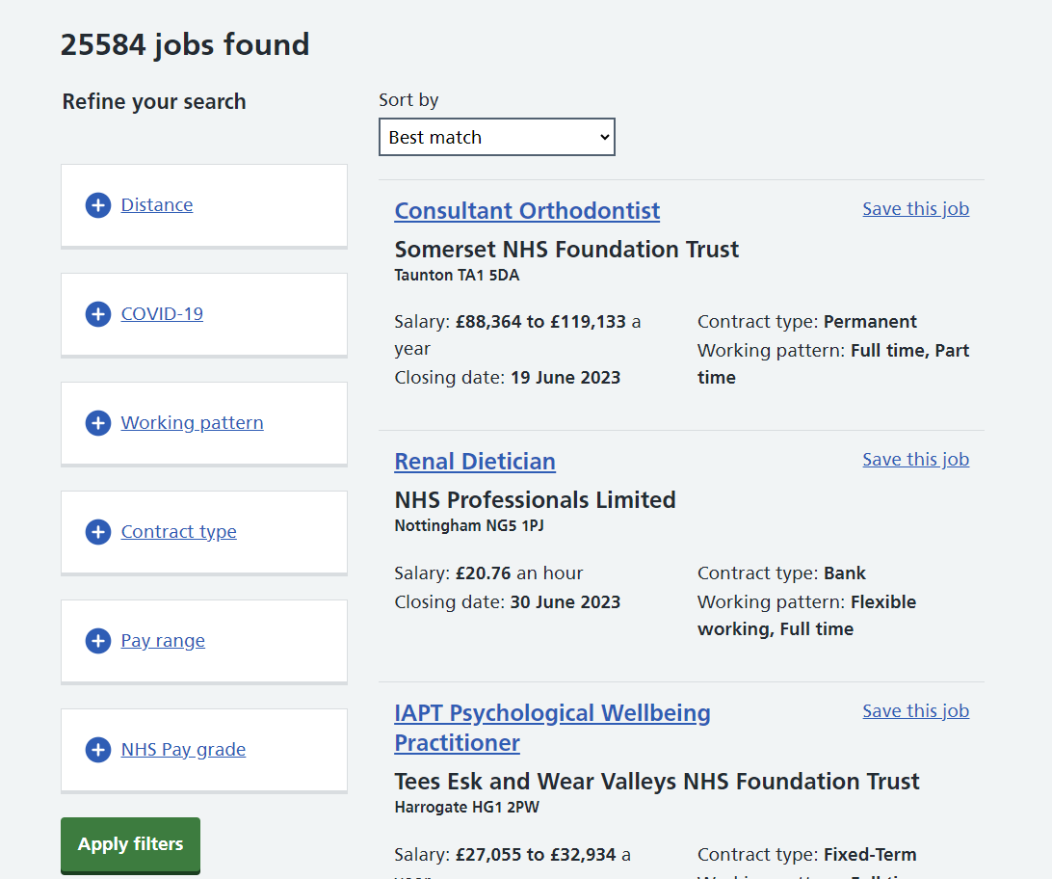

Usage of the NHS Search XML End Point

The NHS Search Service provides an end point that returns the results of searches in XML format. It is intended that this end point can be used by website developers wishing to embed results within their own pages or make use of the data in some other way.

https://www.jobs.nhs.uk/api/v1/search_xml?

The sections below expand on what is contained within each field, and the query parameters that can be used as part of the request URL to search, filter, and sort the vacancy information that is included in the response document.

Xml Response Wrapper (Named “nhsJobs”)
Field | Description
totalPages | The number of pages in the search
totalResults | The total number of results returned by the search
vacancyDetails | The list of vacancy details not wrapped. The XML Response Wrapper will thus contain multiple (up to 10 per page) instances of this tag

Vacancy Details
Field | Description
Id | The unique identifier for this vacancy
title | The Job Title for this vacancy
employer | The name of the Employer that created this vacancy
description | Contains a truncated segment of the job overview for the vacancy, an introduction to the job rather than a long form job description
closeDate | The closing date for this vacancy
postdate | The date that this vacancy was posted. Note this can change if a vacancy is updated and re-published
locations | A list of towns and postcodes where the vacancy is located. Nested XML array where each entry is a <location> composed of a town name, a comma, and a post code
reference | The job reference for this vacancy
salary | The salary range for this vacancy, in the format of the following example: "£20,000 to £30,000"
type | The contract type for this vacancy
url | A URL that links to this specific vacancy

XML Example Structure

<?xml version="1.0" encoding="UTF-8"?>
<nhsJobs>
<totalPages>0</totalPages>
<totalResults>0</totalResults>
<vacancyDetails>
<closeDate>2022-01-01</closeDate>
<description>This role for a nurse involves the following duties ...</description>
<employer>Your Local Health Board</employer>
<id>12345</id>
<locations>
<locations>Cardiff, CF14 4XW</locations>
<locations>Newport, NP20 2UB</locations>
</locations>
<postDate>2023-01-01T05:25:50.696544</postDate>
<reference>ABC-123-DFE</reference>
<salary>£20,000 to £30,000</salary>
<title>Nurse</title>
<type>Permanent</type>
<url>https://www.jobs.nhs.uk/candidate/jobadvert/A0000-00-0000</url>
</vacancyDetails>
</nhsJobs>

Usage of the NHS Jobs Search RSS Feed

The NHS Jobs Search Service provides an end point that returns the results of searches in RSS 2.0 format. It is intended that this end point can be used by website developers wishing to embed results within their own pages or subscribe to the feed to make use of the data in some other way.

https://www.jobs.nhs.uk/api/v1/search_rss?

As per the RSS 2.0 standard (version 2.0.11) the end point returns a channel containing Items in XML format. The sections below expand on what is contained within each field, the two non-standard fields that are present in version 1 of this end point, and the query parameters that can be used as part of the request URL to search, filter, and sort the vacancy information that is included in the response feed.

Channel
Field | Standard (Yes/No) | Description
title | Yes | Field will be present in response, but contain no information
description | Yes | Contains details of the search terms used to request this feed
link | Yes | Contains the full URL used to request this feed
language | Yes | Contains the language code for the data contained in this feed. With version 1, this will always be “en-uk”
pubDate | Yes | Contains an RFC 882 formatted Date, representing the date and time that the request for this feed was made
lastBuildDate | Yes | Contains an RFC 882 formatted Date, representing the date and time that the request for this feed was made
Image | Yes | Contains the fields “link” and “url” to use as the image for this feed, consisting of a link containing the full URL used to request this feed, matching the Channel link, and a URL for the NHS logo. An empty title field will also be present
ttl | Yes | Contains the time to live, indicating how long this feed can be cached
count | No | Contains the total number of results returned by the query used to request this feed. Use this in combination with the page query parameter to paginate through the results

Item
Field | Standard (Yes/No) | Description
title | Yes | Contains the Job Title for this vacancy
author | Yes | Contains the name of the Employer that created this vacancy
link | Yes | Contains a URL that links to this specific vacancy
guid | Yes | Contains a URL that links to this specific vacancy in RSS Guid format
pubDate | Yes | Contains an RFC 882 formatted Date, representing the date and time that the Job Advert was published. Note this can change if a vacancy is updated and re-published
description | Yes | Contains a truncated segment of the job overview for the vacancy, an introduction to the job rather than a long form job description
closingDate | No | Contains an RFC 882 formatted Date, representing the closing date for this vacancy

RSS example Structure

<?xml version="1.0" encoding="UTF-8"?>
<rss version="2.0">
<channel>
<title/>
<description>keyword=nurse</description>
<link>https://www.jobs.nhs.uk/api/search_xml?keyword=nurse</link>
<language>en-uk</language>
<pubDate>Wed, 26 Aug 2015 13:00:00 GMT</pubDate>
<lastBuildDate>Wed, 26 Aug 2015 13:00:00 GMT</lastBuildDate>
<image>
<title/>
<link>https://www.jobs.nhs.uk/api/search_xml?keyword=nurse</link>
<url>http://www.jobs.nhs.uk/images/nhs_logos.png</url>
</image>
<ttl>0</ttl>
<count>100</count>
<item>
<title>Nurse</title>
<description>This role for a nurse involves the following duties ...</description>
<author>Your Local Health Board</author>
<link>https://www.jobs.nhs.uk/candidate/jobadvert/A0000-00-0000</link>
<guid>https://www.jobs.nhs.uk/candidate/jobadvert/A0000-00-0000</guid>
<pubDate>Wed, 26 Aug 2015 13:00:00 GMT</pubDate>
<closingDate>Wed, 26 Aug 2015 13:00:00 GMT</closingDate>
</item>
</channel>
</rss>

Making requests – setting up your own search

You can setup up your own search URL by using any of the parameters below to customise your query. These can be used in various combinations to filter and sort your results to your exact need. A few examples of this include:

For “Internal Only” Jobs:
https://www.jobs.nhs.uk/api/v1/search_xml?employerCode=1234&internalOnly=true
https://www.jobs.nhs.uk/api/v1/search_rssl?employerCode=1234&internalOnly=true
https://www.jobs.nhs.uk/candidate/search/results?employerCode=1234&internalOnly=true

For “Nurse” jobs
https://www.jobs.nhs.uk/api/v1/search_xml?keyword=Nurse
https://www.jobs.nhs.uk/api/v1/search_rss?keyword=Nurse
https://www.jobs.nhs.uk/candidate/search/results?keyword=Nurse

For “Paediatric Nurse” jobs
https://www.jobs.nhs.uk/api/v1/search_xml?keyword=Paediatric%20Nurse
https://www.jobs.nhs.uk/api/v1/search_rss?keyword=Paediatric%20Nurse
https://www.jobs.nhs.uk/candidate/search/results?keyword=Paediatric%20Nurse

For specific Employer, sorted by publication date:
https://www.jobs.nhs.uk/api/v1/search_xml?employerCode=1234&sort=publicationDateAsc
https://www.jobs.nhs.uk/api/v1/search_rss?employerCode=1234&sort=publicationDateAsc
https://www.jobs.nhs.uk/candidate/search/results? employerCode=1234&sort=publicationDateAsc

employerCode is unique to each employer and needs to be replaced with your organisations specific code. Additionally, you could add a search form, or search box, on your website where the visitor can enter the term(s) they are searching for. When the visitor activates the search, the values entered would produce the necessary search on the NHS Jobs database and list the results on your website.

Here are a few guidelines concerning constructing your URLs
- All characters should be URL encoded, e.g.
  - spaces should be replaced with %20, e.g. day%20care
  - &s should be replaced with %26
  - Double quotes should be replaced with %22
  - To check for appropriate URL encoding, use an appropriate online tool
- To use parameters in combination, use &s between them (see sample URLs in this document).
Requests made to the NHS Search end points can be customised using the following path parameters. These are parameters that can be included as part of the request URL, and will control the search, filter, and sorting of the response.

Query Attributes
Parameter | Description | Notes / Values
contractType | Provide this parameter to limit search responses to vacancies matching these contract types. | Existing contract types are:  - Permanent  - Training  - Apprenticeship  - Fixed-Term  - Locum  - Secondment  - Voluntary  - Honorary  - Bank  - NHS Reservist
covidJobsOnly | Provide this parameter to limit search responses to only those vacancies which are related to Covid-19 | Value must be: true
location | Provide either a post code or the name of a location. | Requires the distance parameter to also be provided.
distance | Distance in miles from the location specified in the ‘location’ parameter to limit vacancies returned to. | Requires the location parameter to also be provided
employer | Limit response vacancies to those with a matching Employer name
employerCode | Limit response vacancies to those with a matching Employer identifier code
internalOnly | Limit response vacancies to those which should be advertised internally. If employerCode is supplied and this parameter is absent or false, the response will include vacancies that should be advertised internally and externally. If this parameter is present and true, the response will only include vacancies that should be advertised internally | Requires the employerCode parameter to also be provided  Value must be: true
jobReference | Limit response vacancies to those with a matching Job reference number. If provided, then no other filter parameters will be used. This is used for exact matching on a job advert
keyword | Free form keyword based search of vacancy description and other fields
page | Provide this parameter to return the specified page of the search results. Each page contains a maximum of 10 vacancies
payBandFilter | Limit response vacancies to those matching one of the provided pay bands. Provide pay bands in a comma separated format
payRange | This parameter is an extension of both salaryFrom and salaryTo, allowing you to provide multiple pay ranges. Pay ranges should be provided in the form of the upper and lower bounds of the range in thousands of pounds (the “from” and “to”) separated by a “-“ dash character, for example, “40-50” is a pay range filter of between £40,000 and £50,000 | Upper and lower ranges need to be separated with a “-“
publishedFrom | Limit response vacancies to those published after this provided date and time | Supported formats for date include yyyy-MM-dd, yyyy-MM-dd'T'HH:mm:ss.SSS where seconds and milliseconds are optional, and the 4 digit year RFC 822 date times returned by the RSS endpoint, like “Wed, 26 Aug 2015 13:00:00 GMT” where the name of the day is optional
salaryFrom | Filter out any vacancies with a salary lower than this provided number
salaryTo | Filter out any vacancies with a salary higher than this provided number
sort | Sort the vacancies found by the search. | One of the following options:  - distance – sort by distance from provided location  - closingDate – sort by soonest closing date first  - salaryAsc – sort by salary in ascending order  - salaryDesc – sort by salary in descending order  - publicationDate - sort by publication date in descending order  - publicationDateDesc - sort by publication date in descending order  - publicationDateAsc - sort by publication date in ascending order
workingPattern | Limit response vacancies to those matching the provided working pattern. | One or more of the following options:  - full-time  - part-time  - job-share  - flexible-working  - remote-working  - compressed-hours  - term-time-hours  - annualised-hours

Support

For any support using this NHS Jobs feature, please contact:
nhsbsa.nhsjobs@nhsbsa.nhs.uk

API Spec

Document Revision
Version | Date | Author | Issue
0.01 | 19/4/2023 | Daniel Dowling | First draft
0.06 | 16/06/2023 | Kyle Anderson | Various draft amendments
1.0 | 16/06/2023 | Kyle Anderson | Baseline version 1.0
1.01 | 20/06/2023 | Kyle Anderson | Fixed an error in URL path
1.02 | 17/07/2023 | Daniel Dowling | Added new contract type “NHS Reservist”  Fixed issue in swagger related to workingPattern

