eOPS v2 dashboard guidance

Interactive Contents
Use these interactive contents list to jump straight to the content you want to see.
Just click the titles below to go directly to that section:
eOPS2 - NHS England Ophthalmic Dashboard v2
GOS 1 - Sight Tests
GOS 3 - Vouchers
GOS 3 - Supplements
GOS 4 - Repairs, Replacements & Small Glasses
GOS 6 - Mobile Sight Tests

eOPS2 - NHS England Ophthalmic Dashboard v2

Dashboard Name
NHS England Ophthalmic Dashboard v2
This is also referred to as eOPS2.
This section is designed to complement the NHSBSA eOPS2 v2 Dashboard to provide context on the different types of analyses & information presented.
- eOPS2 uses a claim level patient dataset from PCSE.
- All reports are currently based on 7 NHS regions & 42 Sustainability and Transformation Partnerships (STPs)
- All references to Year refer to Calendar Year and NOT Financial Year.
- Do make use of the hover text inside of graphs and other analysis. These can be useful to identify exactly each data point and other related information.
- This guidance doesn’t display every graphic or analysis available within eOPS, for instance GOS 4 Repairs have been described but additional graphs & tables for GOS 4 Replacements and GOS 4 Small Glasses have been omitted. The logic applied to one can apply to all similar graphs.
For further help and guidance, you can contact the NHSBSA Ophthalmic Insight team at: eopssupport@nhsbsa.nhs.uk

GOS 1 - Sight Tests
Analysis Name | Analysis Description | Image
Total GOS 1 Sight Tests | The total count of all NHS GOS 1 Sight Tests Contracts where NHS Sight Test count > 0, for the Organisation level and Calendar Year/Month selected. | 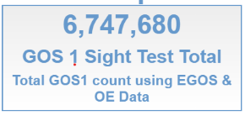
EGOS % of total GOS 1 sight tests | % of total count of all GOS 1 Sight Tests which are EGOS, for the Organisation level and FY selected. | 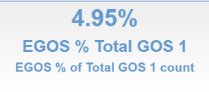
Total OE GOS 1 sight tests | The total count of NHS GOS 1 Sight Tests Contracts as reported in Open Exeter where NHS Sight Test count > 0, for the Organisation level and Calendar Year/Month selected. | 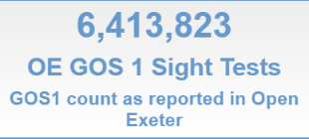
Total EGOS GOS 1 sight tests | The total count of NHS EGOS 1 Sight Tests Contracts as where NHS Sight Test count > 0, for the Organisation level and Calendar Year/Month selected. | 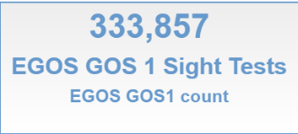
Total GOS 1 Sight Tests Line Graph | A Line graph showing the count of total GOS 1 Sight Tests by Month, for the Calendar Year selected. | 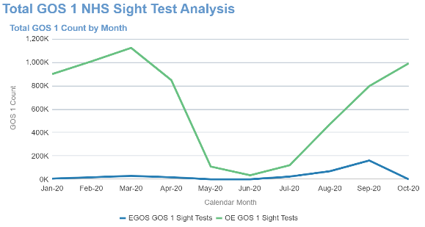
Total GOS 1 Sight Test Pivot Table | A table of values showing the total count of GOS 1 Sight Tests by month, for the Calendar Year selected. | 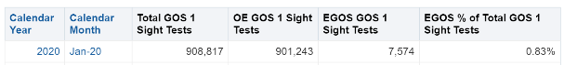
Total EGOS - GOS 1 Sight Tests Line Graph | A Line graph showing the count of total GOS 1 Sight Tests by Month, for the Calendar Year selected. | 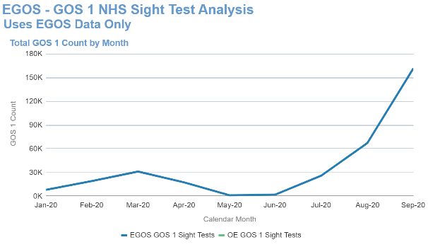
Total GOS 1 Sight Tests Age Band Line Graph | A Line graph showing the count of total GOS 1 Sight Tests by Month, for the Calendar Year selected split by age band | 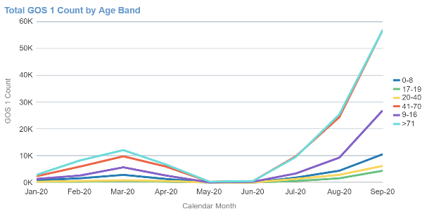
Total GOS 1 Sight Tests by Year Line Graph | A Line graph showing the count of total GOS 1 Sight Tests by Calendar Year. | 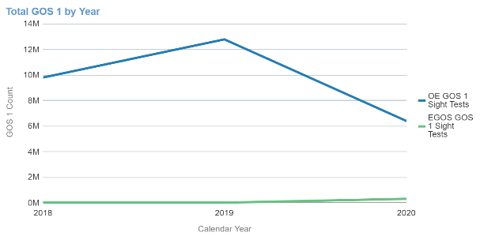
Total GOS 1 Sight Tests by Year Pivot Table | A table of values showing the total count of GOS 1 Sight Tests by Calendar Year. | 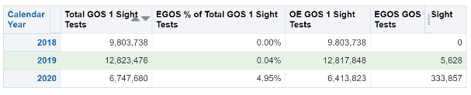
EGOS - Total GOS1 | Total count of EGOS GOS1. | 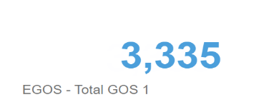
Reporting Orgs | Total count of the reporting organisation | 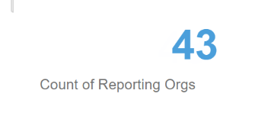
GOS 1 Average per Org | Average count of GOS 1 per organisation | 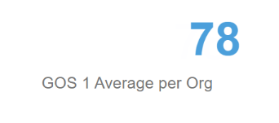
EGOS GOS 1 Count by Month | Count of EGOS GOS 1 by month for the time period and organisation selected | 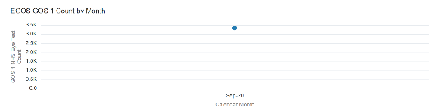
EGOS GOS1 by Contractor | Count of EGOS GOS 1 by Contractor for the time period and organisation selected | 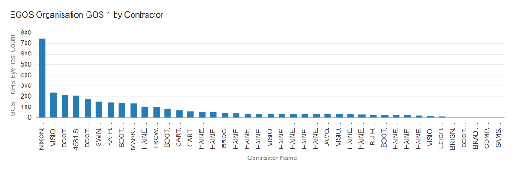
GOS 1 count by STP & Contactor | Map showing the GOS 1 count by STP & Contractor, the larger the bubble indicates the higher GOS 1 count | 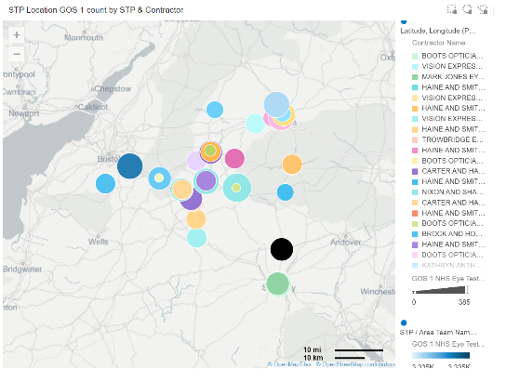
EGOS – GOS 1 Retest Summary | Count of total GOS 1 resets for the time period & organisation selected | 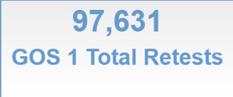
EGOS GOS 1 Retest Trend | Line chart showing the trend of the count of EGOS GOS 1 retests for the time period & organisation selected | 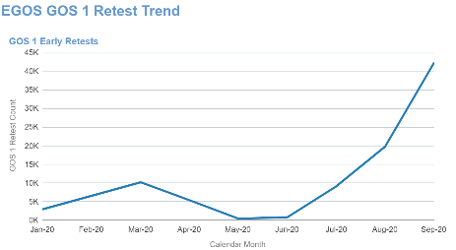
EGOS GOS 1 Retest total by Reason | Chart showing the count of EGOS GOS 1 retests by reason for the time period & organisation selected | 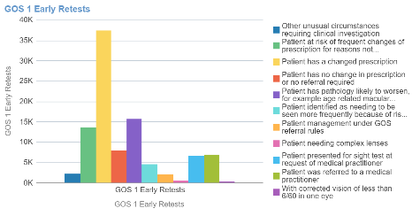
EGOS GOS 1 Retest Count by Retest Reason | Table showing the count of EGOS GOS 1 retests by reason for the time period & organisation selected | 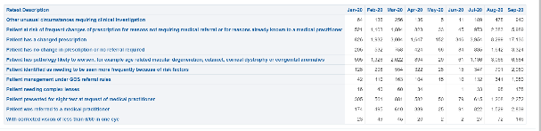
Percentage of EGOS GOS 1 Retest Reason by Age Band | Chart showing the trend of the percentage of EGOS GOS 1 retests by age band for the time period & organisation selected | 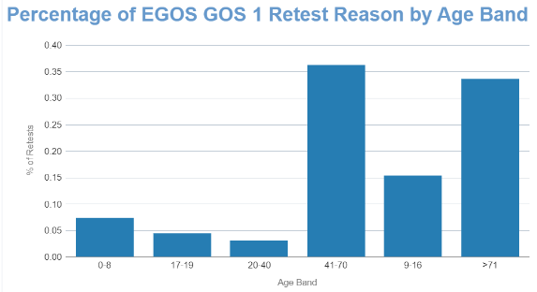
EGOS - GOS 1 Retests by Age Band and Reason | Chart showing the trend of the percentage of EGOS GOS 1 retests by reason & age band for the time period & organisation selected | 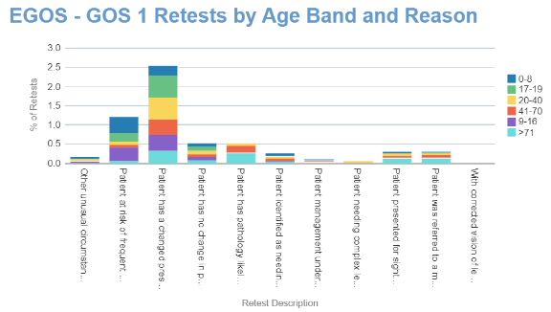
Percentage of EGOS GOS 1 Retest Reason by Age Band | Table showing the trend of the percentage of EGOS GOS 1 retests by reason & age band for the time period & organisation selected | 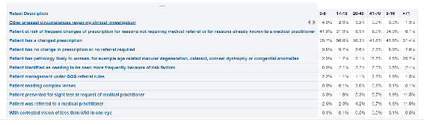
EGOS - GOS 1 Eligibility Indicators – Evidence seen | Percentage of EGOS – GOS 1 where evidence has been seen for the time period & organisation selected | 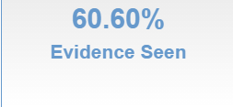
EGOS - GOS 1 Eligibility Indicators – Records seen | Count of total EGOS – GOS 1 records seen for the time period & organisation selected | 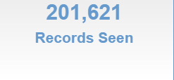
EGOS - GOS 1 Eligibility Indicators – Total records | Count of total EGOS – GOS 1 records for the time period & organisation selected | 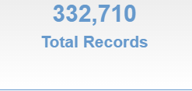
Eligibility Seen % of EGOS - GOS 1 Sight Test Applications | Line chart showing the trend of the percentage of EGOS GOS 1 where evidence is seen for the time period & organisation selected | 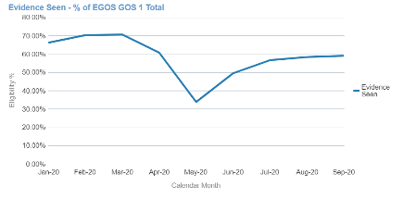
Eligibility Seen % of EGOS - GOS 1 Sight Test Applications | Line chart showing the trend of the percentage of EGOS GOS 1 by age band where evidence is seen for the time period & organisation selected | 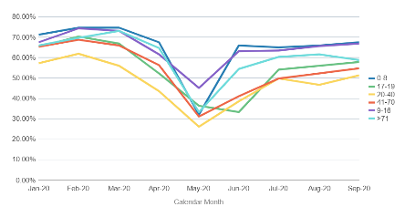
Percentage of EGOS GOS 1 Sight Tests by Eligibility Reason | Pivot table showing the percentage of EGOS GOS 1 sight tests by eligibility reason for the time period & organisation selected | 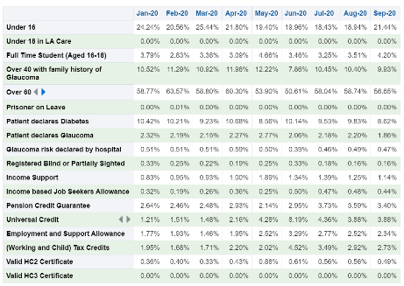
Percentage of EGOS GOS 1 Sight Tests by Eligibility Reason | Line chart showing trend over time for the percentage of EGOS GOS 1 sight tests by eligibility reason for the time period & organisation selected | 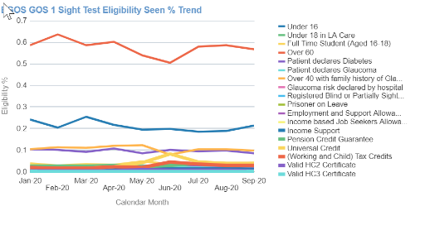

GOS 3 - Vouchers
Total GOS 3 Vouchers | Total OE & EGOS GOS 3 Vouchers This combines Paper and Electronic Total Voucher Counts (Not Claims) | 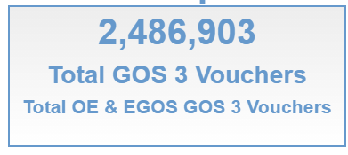
EGOS GOS 3 Voucher % | Tile showing the % of EGOS GOS 3 vouchers from all GOS 3 vouchers | 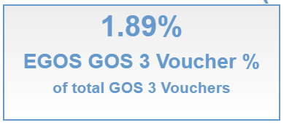
QR – GOS 3 Vouchers Total OE GOS 3 Vouchers | Tile showing the total OE GOS 3 vouchers | 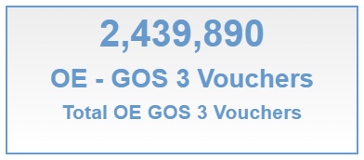
Total GOS 3 voucher count by month | Line chart showing a monthly trend of the Total GOS 3 vouchers, OE – GOS 3 Voucher total and EGOS – GOS 3 Voucher total | 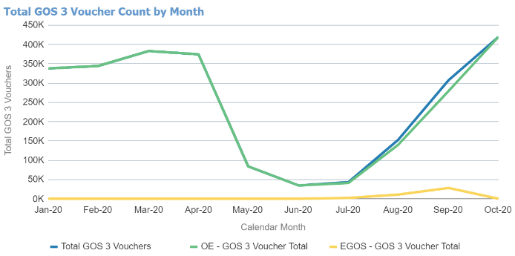
Total GOS 3 voucher by type | Bar chart showing the GOS 3 voucher type breakdown for each month | 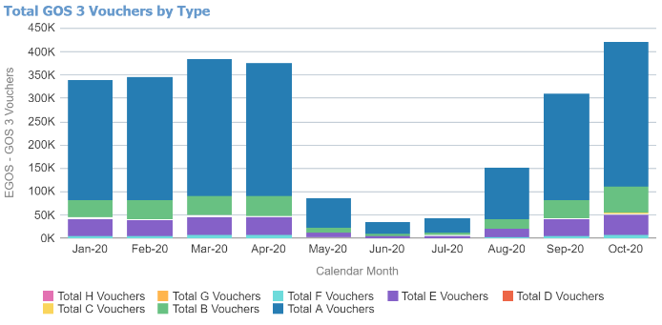
Total GOS 3 Vouchers by Year | Bar chart showing the GOS 3 voucher type breakdown for each calendar year | 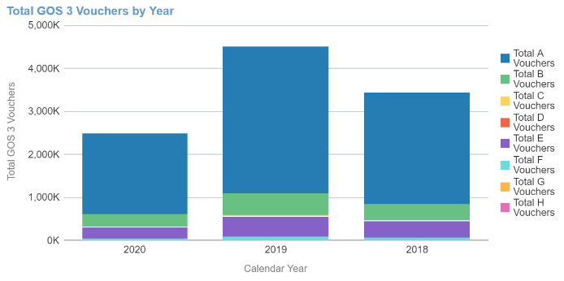
Table | Table of data broken down by calendar year | 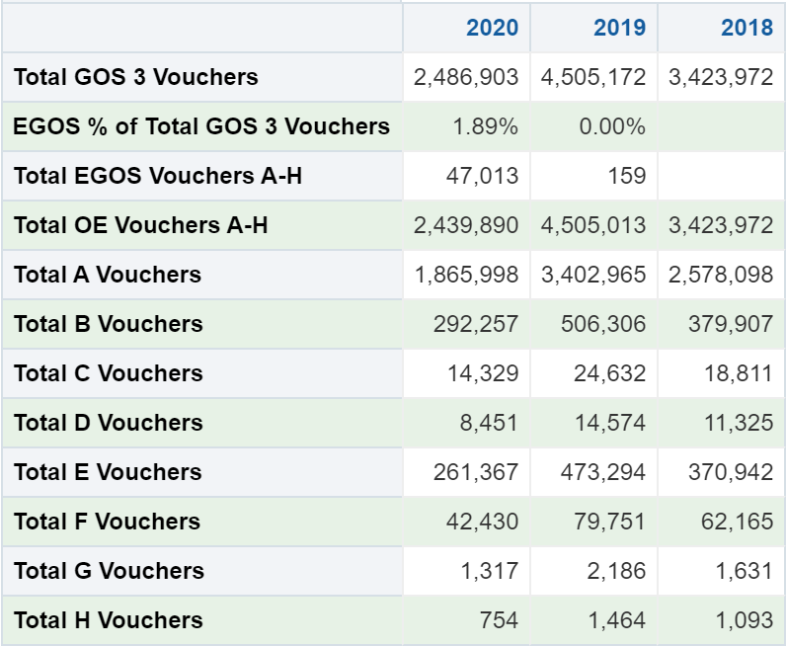
EGOS GOS 3 Voucher Total | Shows the count of ALL vouchers issued for the Organisation level for selected time period. | 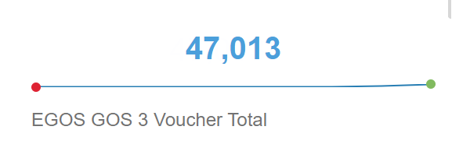
Average GOS 3 by Region | Shows the region average count of vouchers | 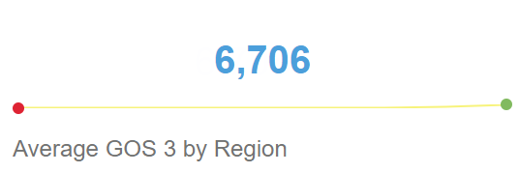
Average GOS 3 by Month | Shows the monthly average count of vouchers | 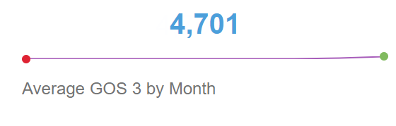
Total GOS 3 Vouchers Graph | A graph showing the total count of ALL vouchers by month, for the selected time period. | 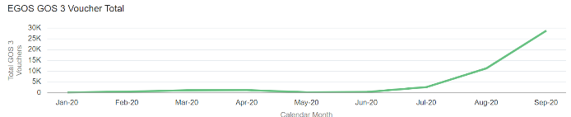
Voucher A-H Graph | A graph showing the count of vouchers A-H by region for the selected time period. | 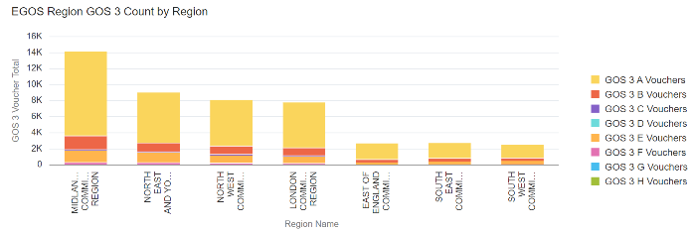
STP Location GOS 3 Count by Region & STP | A map with bubbles representing the total count of GOS 3 by STP, for the selected time period | 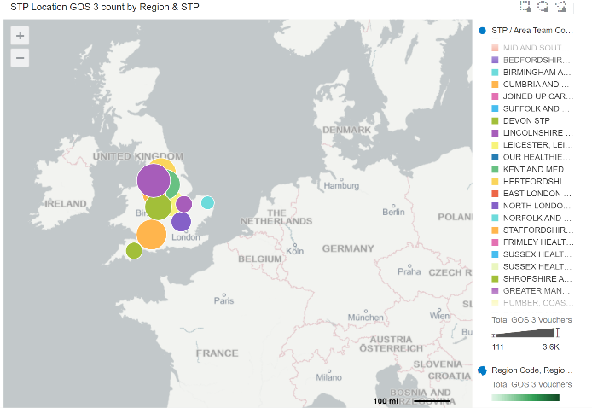
EGOS - GOS 3 Eligibility Indicators – Evidence Seen | Percentage of EGOS – GOS 3 vouchers where evidence has been seen for the time period & organisation selected | 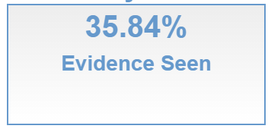
EGOS - GOS 3 Eligibility Indicators – Record Seen | Count of total EGOS – GOS 3 vouchers seen for the time period & organisation selected | 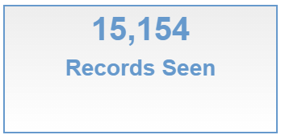
EGOS - GOS 3 Eligibility Indicators – Total Records | Count of total EGOS – GOS 3 vouchers for the time period & organisation selected | 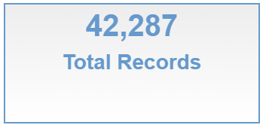
EGOS - GOS 3 Eligibility trend – Evidence Seen | Line chart showing the trend of the percentage of EGOS GOS 3 vouchers where evidence is seen for the time period & organisation selected | 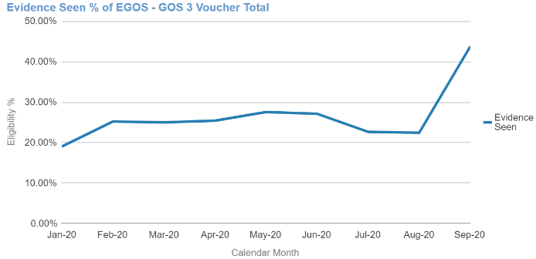
EGOS - GOS 3 Eligibility trend – Evidence Seen by Age band | Line chart showing the trend of the percentage of EGOS GOS 3 vouchers by age band where evidence is seen for the time period & organisation selected | 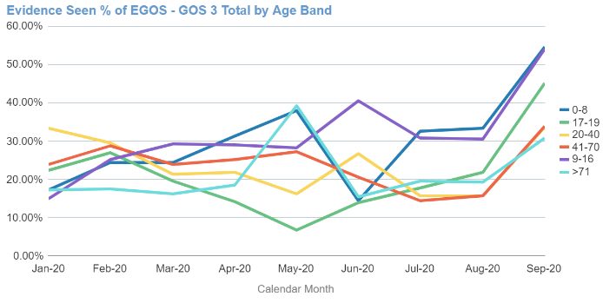
EGOS - GOS 3 Eligibility Indicators | Pivot table showing the percentage of EGOS GOS 3 vouchers by eligibility reason for the time period & organisation selected | 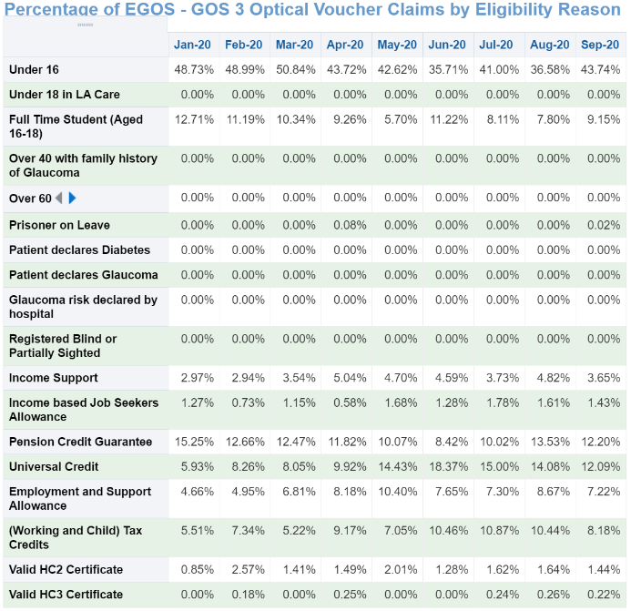
EGOS - GOS 3 Eligibility Indicators | Line chart showing trend over time for the percentage of EGOS GOS 3 vouchers by eligibility reason | 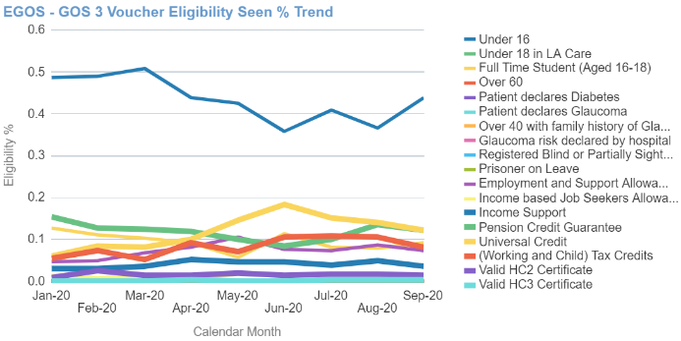

GOS 3 - Supplements
Total GOS 3 Supplements | The total count of all GOS 3 supplements, for the Organisation level or FY selected. | 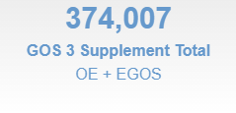
Voucher % with supplement | Tile showing the % of GOS 3 vouchers with supplement | 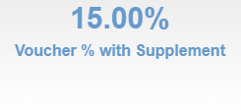
GOS 3 Supplement Total | Count of total OE GOS 3 Supplements | 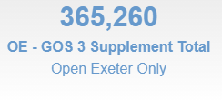
EGOS GOS 3 supplement total | Count of total EGOS GOS 3 Supplements | 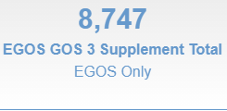
Supplement Total by Month | Total GOS 3 supplements & second pairs by month for the time period and organisation selected | 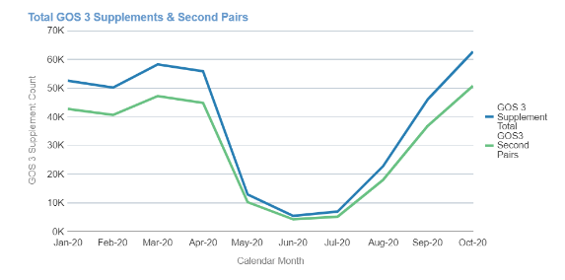
Supplement Total by Month | Total GOS 3 supplements by month & supplement for the time period and organisation selected | 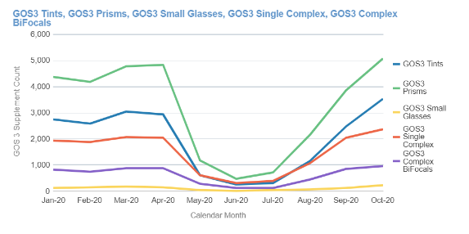
Individual supplement analysis | Bar chart showing supplement split by OE/EGOS & month, drop-down option to select supplement type | 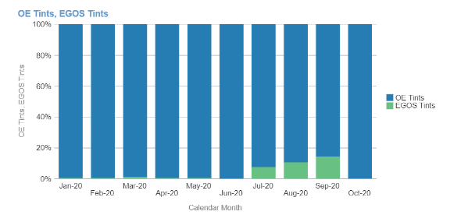
Individual supplement analysis | Pivot table showing the total count by supplement type and month for the calendar year and organisation selected | 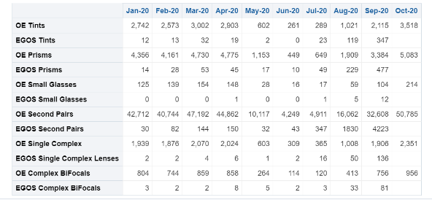
EGOS – Total GOS 3 Supplements | Total EGOS GOS 3 Supplements | 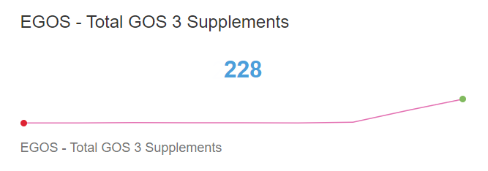
EGOS GOS 3 Supplements (Excl. 2nd Pairs) | Total EGOS GOS 3 Supplements (excluding 2nd pairs) | 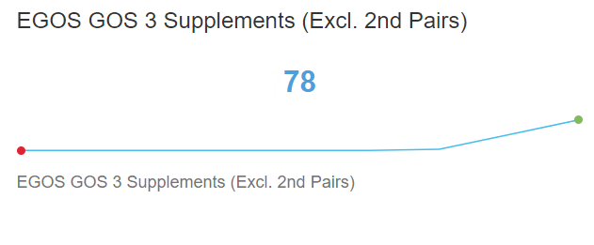
EGOS GOS 3 Supplement Trend | Line chart showing trend over time for EGOS GOS 3 Supplements & EGOS GOS 3 Supplements (excluding 2nd pairs) by month for the calendar year and organisation selected | 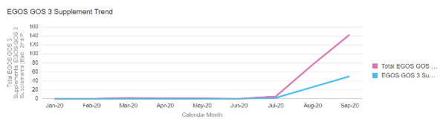
GOS 3 Supplement Count by EOGS Organisation | Bar chart showing the count of EGOS GOS 3 Supplements by organisation for the time period and organisation selected | 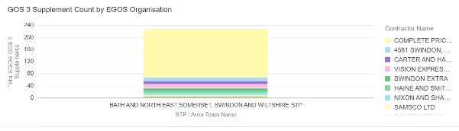
Total GOS 3 Supplement count by STP | Map showing the GOS 3 supplement count by STP, the larger the bubble indicates the higher GOS 3 count | 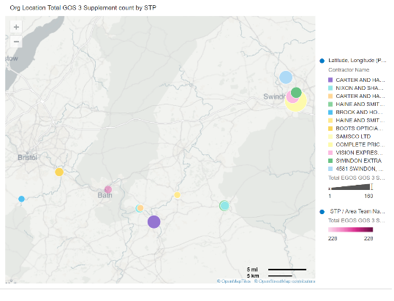

GOS 4 - Repairs, Replacements & Small Glasses
Total GOS 4 Repairs | Shows the total count of Repairs claimed. | 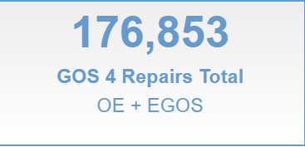
Total GOS 4 Replacements | Shows the total count of Replacements claimed. | 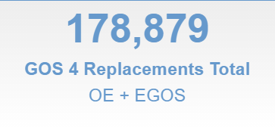
Total GOS 4 Small Glasses | Shows the total count of Small Glasses claimed. | 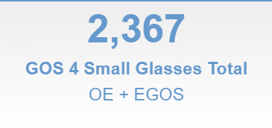
Total GOS 4 Repairs / Replacement / Small Glasses | A line graph showing the trend over time for count of GOS 4 claims for the time period & organisation selected | 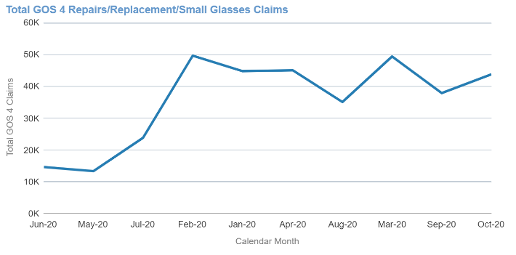
GOS 4 claims by type | A line graph showing the trend over time for count of GOS 4 claims by type for the time period & organisation selected | 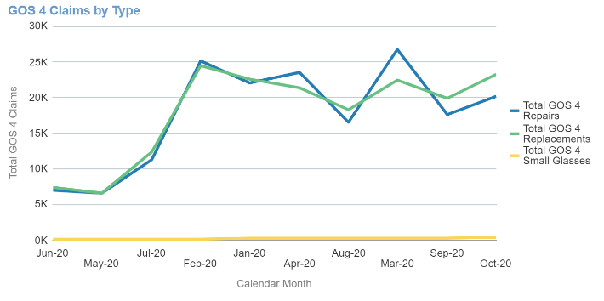
GOS 4 by Year chart | Total GOS 4 claims by Calendar year | 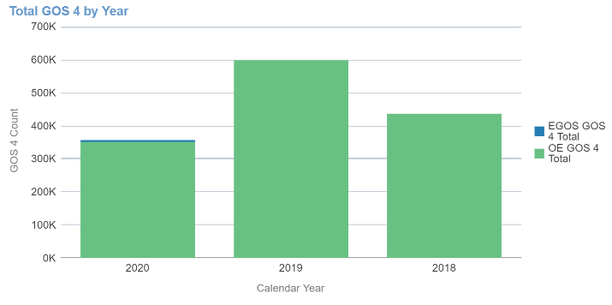
GOS 4 by Year pivot table | Total GOS 4 claims by Calendar year | 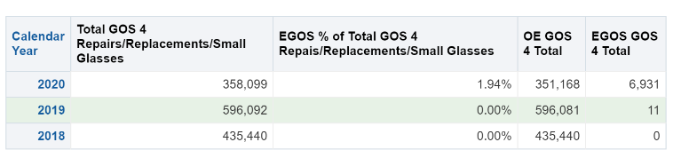
Total EGOS GOS 4 claims | Total EGOS GOS 4 claims | 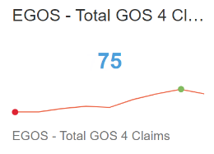
EGOS GOS 4 Repairs | Total EGOS GOS 4 Repairs | 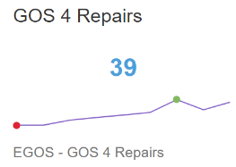
EGOS GOS 4 Replacements | Total EGOS GOS 4 Replacements | 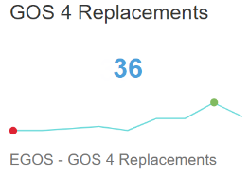
EGOS GOS 4 Small Glasses | Total EGOS GOS 4 Small Glasses | 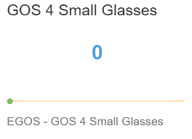
EGOS GOS 4 Trend by Month | Line chart showing the count of EGOS GOS 4 claims by month & type | 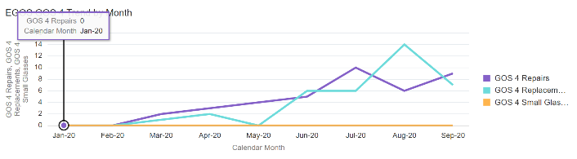
EGOS GOS 4 count by STP | Bar chart showing the count of EGOS GOS 4 claims by STP | 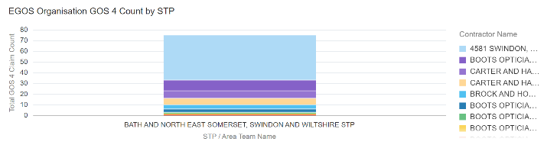
Total GOS 4 claims count by STP | Map showing the GOS 4 count by STP, the larger the bubble indicates the higher GOS 4 count | 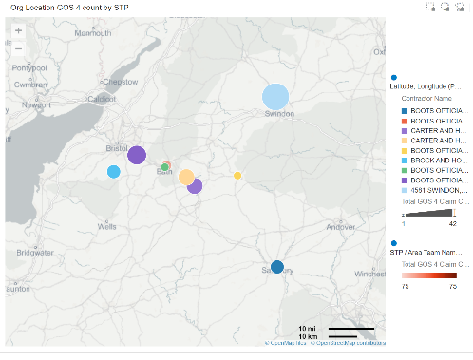
EGOS - GOS 4 Eligibility Indicators – Evidence seen | Percentage of EGOS – GOS 4 where evidence has been seen for the time period & organisation selected | 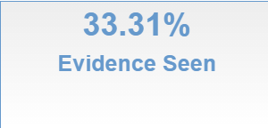
EGOS - GOS 4 Eligibility Indicators – Records seen | Count of total EGOS – GOS 4 claims seen for the time period & organisation selected | 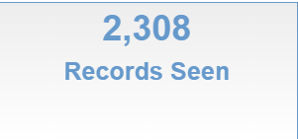
EGOS - GOS 4 Eligibility Indicators – Total records | Count of total EGOS – GOS 4 claims for the time period & organisation selected | 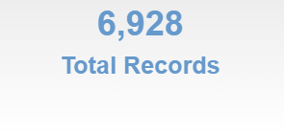
Eligibility Seen % of EGOS - GOS 4 claims | Line chart showing the trend of the percentage of EGOS GOS 4 where evidence is seen for the time period & organisation selected | 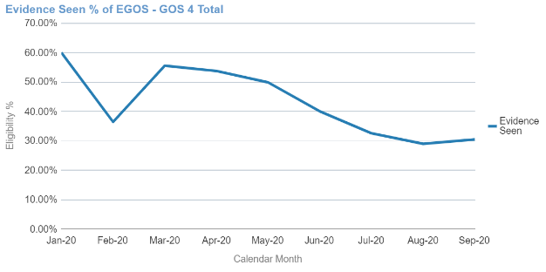
Eligibility Seen % of EGOS - GOS 4 claims | Line chart showing the trend of the percentage of EGOS GOS 4 claims by age band where evidence is seen for the time period & organisation selected | 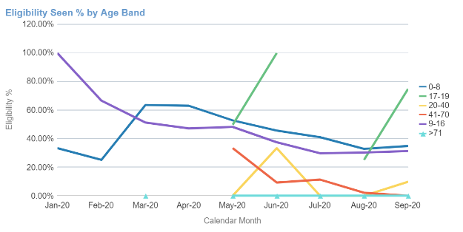
Percentage of EGOS GOS 4 claims | Pivot table showing the percentage of EGOS GOS 4 claims by eligibility reason for the time period & organisation selected | 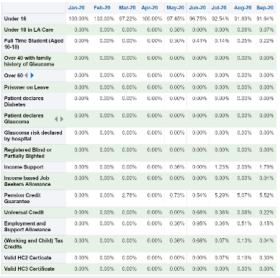
Percentage of EGOS GOS 4 claims by Eligibility Reason | Line chart showing trend over time for the percentage of EGOS GOS 4 claims by eligibility reason | 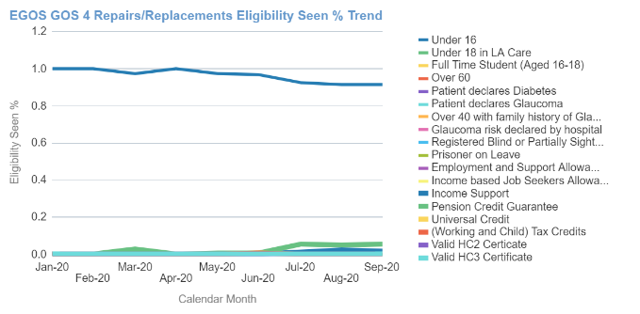

GOS 6 - Mobile Sight Tests
Total GOS 6 Mobile Sight Tests | The total count of NHS GOS 6 Mobile Sight Tests Contracts where NHS Mobile Sight Test count > 0, for the Organisation level and Calendar Year/Month selected. | 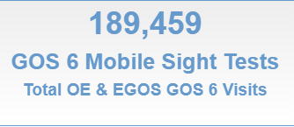
EGOS % of total GOS 6 Mobile sight tests | % of total count of all GOS 6 Mobile Sight Tests which are EGOS, for the Organisation level and FY selected. | 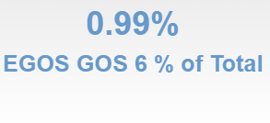
Total OE GOS 6 Mobile sight tests | The total count of NHS GOS 6 Mobile Sight Tests Contracts as reported in Open Exeter where NHS Mobile Sight Test count > 0, for the Organisation level and Calendar Year/Month selected. | 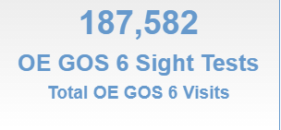
Total EGOS GOS 6 Mobile sight tests | The total count of NHS EGOS 6 Mobile Sight Tests Contracts as where NHS Mobile Sight Test count > 0, for the Organisation level and Calendar Year/Month selected. | 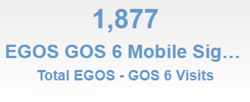
Total GOS 6 Mobile Sight Tests Line Graph | A Line graph showing the count of total GOS 6 Mobile Sight Tests by Month, for the Calendar Year selected. | 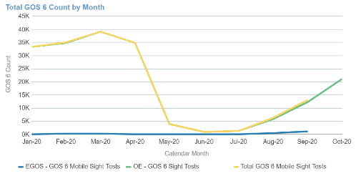
Total GOS 6 Mobile Sight Test | A bar chart showing the total count of GOS 6 Mobile Sight Tests by quarter, for the Calendar Year selected. | 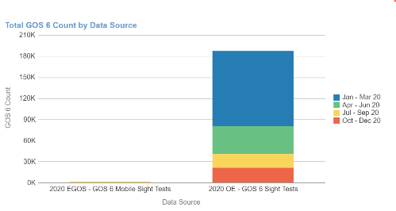
Total GOS 6 Mobile Sight Tests bar chart | A bar chart showing the count of total GOS 6 Mobile Sight Tests by Calendar. | 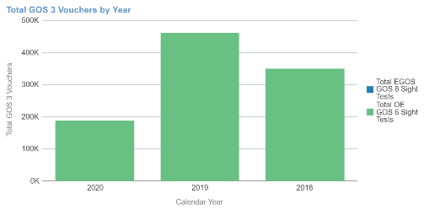
Total GOS 6 Mobile Sight Tests pivot table | A pivot table showing the count of total GOS 6 Mobile Sight Tests by Calendar. | 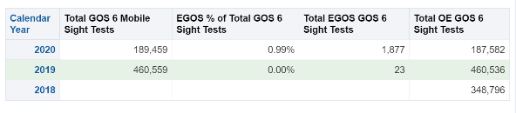
EGOS - Total GOS 6 Vouchers | Total count of EGOS GOS 6 vouchers | 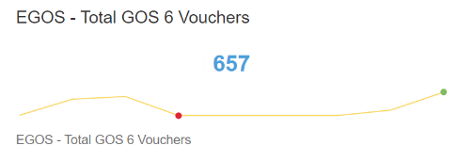
Reporting Orgs | Total count of the reporting organisation | 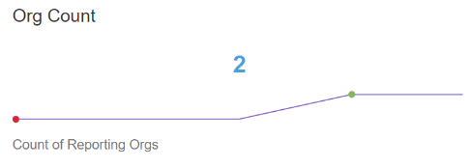
EGOS GOS 6 Count by Month | Count of EGOS GOS 6 by month for the time period and organisation selected | 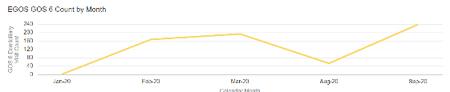
GOS 6 count by STP | Total GOS 6 count by STP for the organisation and time period selected | 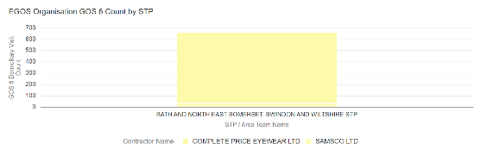
GOS 6 count by STP | Map showing the GOS 6 count by STP, the larger the bubble indicates the higher GOS 6 count | 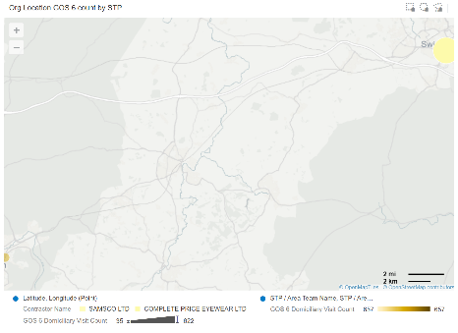
EGOS - GOS 6 – Evidence seen | Percentage of EGOS – GOS 6 where evidence has been seen for the time period & organisation selected | 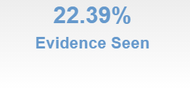
EGOS - GOS 6 Eligibility Indicators – Records seen | Count of total EGOS – GOS 6 claims seen for the time period & organisation selected | 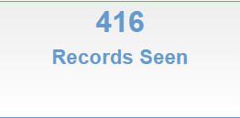
EGOS - GOS 6 Eligibility Indicators – Total records | Count of total EGOS – GOS 6 claims for the time period & organisation selected | 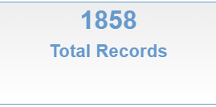
Eligibility Seen % of EGOS GOS 6 – Domiciliary Visits | Line chart showing the trend of the percentage of EGOS GOS 6 – Domiciliary Visits where evidence is seen for the time period & organisation selected | 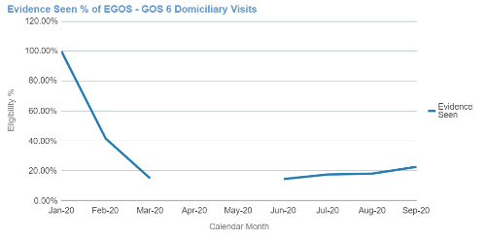
Eligibility Seen % of EGOS GOS 6 – Domiciliary Visits | Line chart showing the trend of the percentage of EGOS GOS 6 – Domiciliary Visits by age band where evidence is seen for the time period & organisation selected | 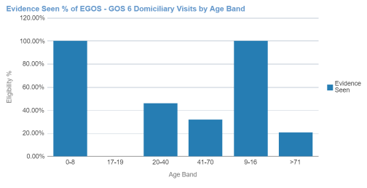
Percentage of EGOS GOS 6 – Domiciliary Visits by Eligibility Reason | Pivot table showing the percentage of EGOS GOS 6 – Domiciliary Visits by eligibility reason for the time period & organisation selected | 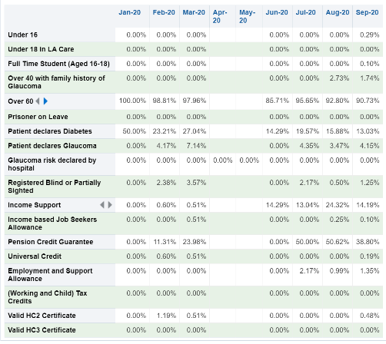
Percentage of EGOS GOS 6 – Domiciliary Visits by Eligibility Reason | Line chart showing trend over time for the percentage of EGOS GOS 6 – Domiciliary Visits by eligibility reason for the time period & organisation selected | 