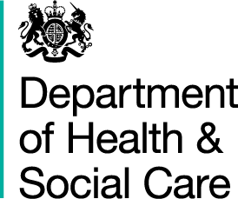

I am writing to provide an update on the future of the Dental Contract Reform Programme, as the regulations which support this work expire on 31st March 2022.
The Department is very grateful for, and recognises the hard work, dedication and time that you and your team have put into the dental contract reform programme over the years.
As part of the programme, we have learnt valuable lessons, including the important contributions that the wider dental professional team can provide to patients, the value of recording individual patient clinical risk and how this supports evidence-based care pathway decisions. This comes alongside learning on the challenges of measuring and monitoring preventative care and the need for robust implementation support to facilitate widespread change.
However, as you are already aware there were more concerning findings following consideration of the six aims for national contract reform to be viable as outlined in the letter to all NHS primary care dental contract holders dated 29th March 2021. These include a fall in the numbers of patients able to access care, which mean that it is not possible to roll out the prototype approach more widely as we continue to recover from the impact of COVID-19 on dental services. We intend to publish the evaluation of the prototype programme later this year. The report will describe the benefits and positive findings, as well as outlining the concerns about the prototype contract that were raised by the findings.
We will invite you to join a meeting between 5:30pm and 7pm on 1 November where we will give you early sight of the evaluation findings and explore how the key learnings from the programme will support the ongoing system reform work, which is now being led by NHS England and Improvement.
As a result of the expiration of The National Health Service (Dental Services) (Prototype Agreements) 2015 regulations, all prototype practices currently within the programme will be returned to their underlying GDS or PDS contracts in April 2022. We recognise that this may be a cause of some anxiety and that practices may require some additional support to manage this transition. To help us understand any support which may be required in more detail we would like to invite you to a further workshop in early December, which we will provide details of soon. Within this workshop we propose to work with you and NHSEI to explore the key challenges which may be faced in transitioning back to your underlying contracts and any changes which will be required to support you during this transition.
Finally, I would like to encourage you to continue providing NHS dental services for your patients wherever possible. Whilst this change may be challenging, I would like to provide reassurance that the Government, Department of Health and Social Care and NHS England and NHS Improvement have a renewed commitment to reforming the provision of NHS dental care in England and are clear that any new contract needs to meet the needs of patients, dentists and their teams.
Kind regards,
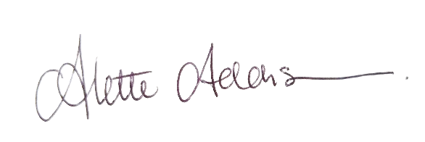
Alette Addison
Deputy Director - Pharmacy, Dentistry and Eye Care
Department of Health and Social Care

