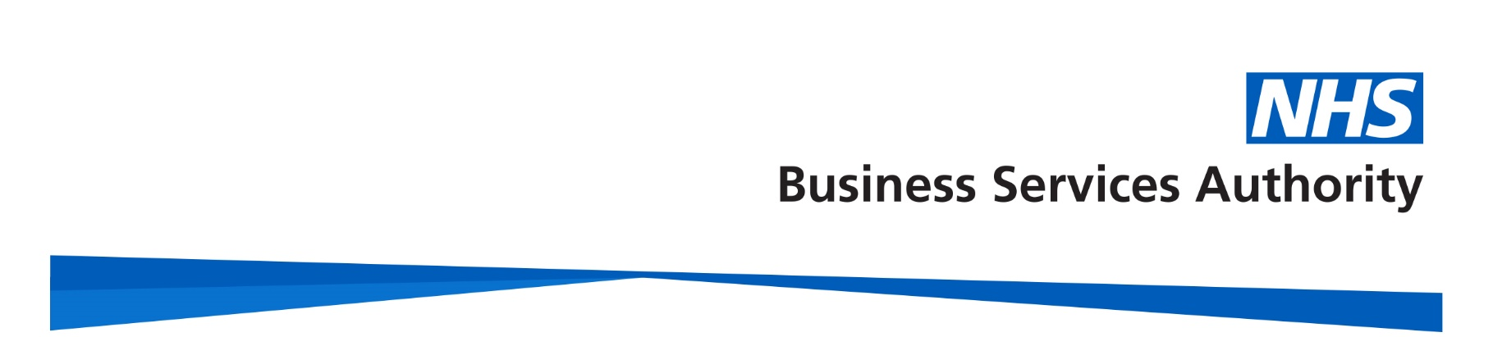

Introducing the government changes to remove age discrimination from public service pension schemes
Video transcript

In 2015 the government made changes to most public service pension schemes, including the NHS Pension Scheme.

The changes did not apply to those members closest to retirement.

Members closest to retirement were able to stay in the 1995/2008 Scheme with full or tapered protection.

The Court of Appeal found this protection discriminated against younger members.

The government is fixing this age discrimination in public service pension schemes.

Who is affected?

If you joined a public service pension scheme on or before 31 March 2012 and you were a member of the scheme on or after 1 April 2015, NHS Pensions will be in touch because this affects you.

You’re also affected if you left the public service scheme 31 March 2012 but returned within 5 years

If you joined a public service pension scheme after 31 March 2012 you’re not affected.

If you’re affected, when you retire you’ll be asked to decide which pension scheme benefits you’d like to receive for your service between 1 April 2015 and 31 March 2022.

This is called the remedy period

Asking you to make this choice when you retire means you’ll know what you’re entitled to under each option, making it easier to make the right decision for you.

We’ll provide you with information at the time to help you make your decision.

The government is introducing new legislation and intends for affected members to be able to make a choice at retirement from 1 October 2023.

If you’ve already retired or retire before 1 October 2023, we’ll write to you and ask you to make your choice retrospectively.

If you’re owed any money, we’ll backdate all payments to your date retirement.

From 1 April 2022 all active members will be members of the 2015 NHS Pension Scheme.

From 1 April 2022, all legacy public service pension schemes will be closed, including the 1995/2008 NHS Pension Scheme.

Anything you’ve earned in the 1995/2008 Scheme before 1 April 2022 will stay in that scheme. You’ll be able to access these benefits in the same way and at the same time as you can now.

Any pension benefits you earn on or after the 1 April 2022 will be in the 2015 Scheme.

For now, all our processes will stay the same and there is nothing you need to do.

We’ll updated our website as more information is available and we’ll contact all affected members directly when you need to take action.

For more information or to find out if you’re affected, visit:

www.nhsbsa.nhs.uk/nhs-pensions

