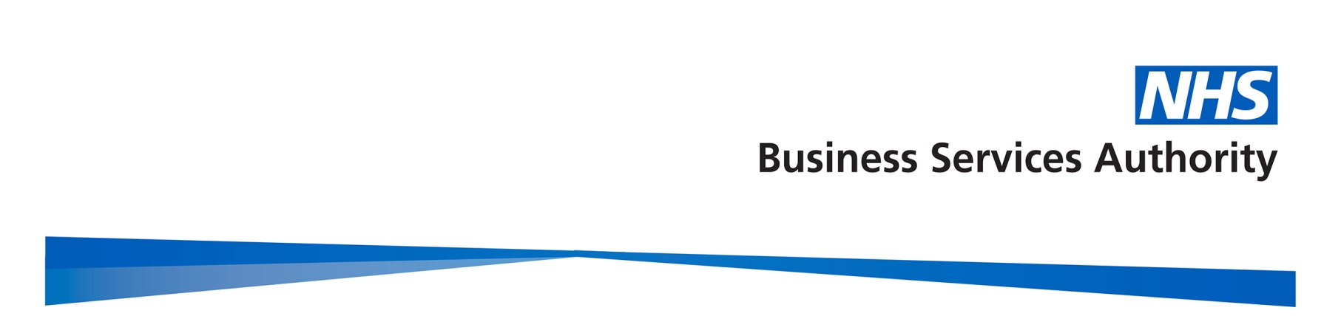

Gender Pay Gap Report

2018/19

Contents
Contents 2
Introduction 3
Gender summary of workforce 4
Proportion of males and females in each pay band 4
Hourly Rate by gender for each band.………………………………………………………...6
Mean and Median pay gap per band…………………………………………………….……7
Proportion of males and females in each pay quartile 10
Gender pay gap in hourly pay 11
Mean gender pay gap in hourly pay 11
Median gender pay gap in hourly pay 11
Bonus gender pay gap 12
Proportion of males and females receiving a bonus payment 12
Mean and median bonus gender pay gap 12
Summary 13
Actions to remove the gender pay gap 14

Introduction

Under the Equality Act 2010 (Specific Duties and Public Authorities) Regulations 2017, the NHS Business Services Authority (NHSBSA), along with all public bodies with more than 250 employees, is required to publish gender pay gap information by 30th March each year. This includes information on the mean and median gender gaps in hourly pay, the mean and median gender gaps in bonus pay, the proportion of men and women who received bonuses, and the proportions of male and female employees in each pay quartile.

The gender pay gap shows the difference in the average pay between all men and women in an organisation. It is different to equal pay, which examines the pay differences between men and women who carry out the same or similar jobs, or work of equal value. It is unlawful to pay people unequally because they are a man or a woman.

At the NHSBSA, our people are at the centre of our business strategy and we aspire to be a great place to work, which can recruit and retain the most talented individuals. We’re committed to a diverse and inclusive culture which supports the fair treatment and reward of all colleagues, irrespective of gender, and our pay framework is based on the principles of fairness, transparency and consistency.

This report fulfils not only our reporting requirements, but also sets out what we are doing to address the gender pay gap in our organisation. The data is based on a snapshot of all employees as at 31 March 2019, as this is the date which all public authorities must use each year. The calculations used are those set out in the relevant legislation to ensure the data is calculated consistently across organisations.

Gender profile

Gender summary of workforce

On the 31 March 2019, the NHSBSA employed 2,868 staff. The chart below demonstrates the gender profile of our workforce, which shows that we employ more women (59.4% and 1704 headcount) than men (40.6% and 1164 headcount).
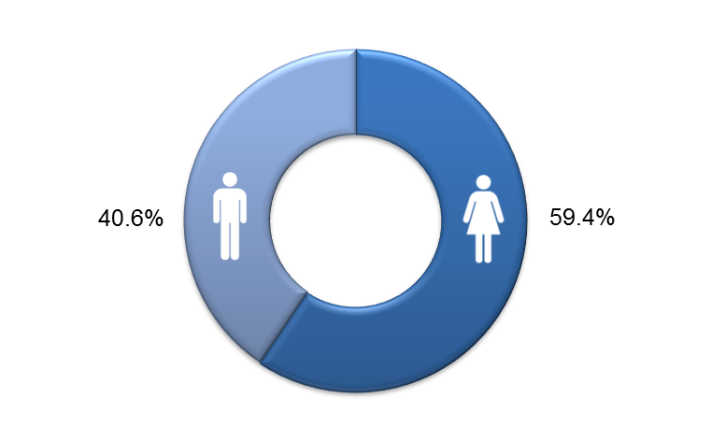

Proportion of males and females in each pay band

The NHSBSA uses NHS Agenda for Change pay bands for the vast majority of staff. Bands vary by levels of responsibility and each band has a set pay range with increments. Colleagues move up the increments in their band so that generally those who have spent longer in the same grade would be expected to earn more, regardless of gender. In addition, we have a small group of employees who are on pay scales other than Agenda for Change. These include colleagues on Civil Service grades who transferred into the NHSBSA, those on NHS Medical and Dental salary scales, and our most senior employees who receive NHS Executive and Senior Manager salaries.

The two charts on the following page show the total headcount of staff within each pay band by gender, and the percentages of men and women within each pay band. The salary scales other than Agenda for Change as described above are shown as ‘Non-AfC’ on the charts.

The charts reveal that the majority of staff are concentrated in the lower pay bands (2 and 3), with 61.5% of all employees being in these two pay bands. In addition, these bands have significantly higher percentages of female colleagues, for example band 3 is 68.5% women to 31.5% men. This over-representation influences the gender pay gap. It is positive to note that the representation of women in the senior pay bands has improved with women accounting for 46.9% (183 headcount) of bands 7-9 in total, compared to 53.1% men (207 headcount).

Headcount by pay band and gender

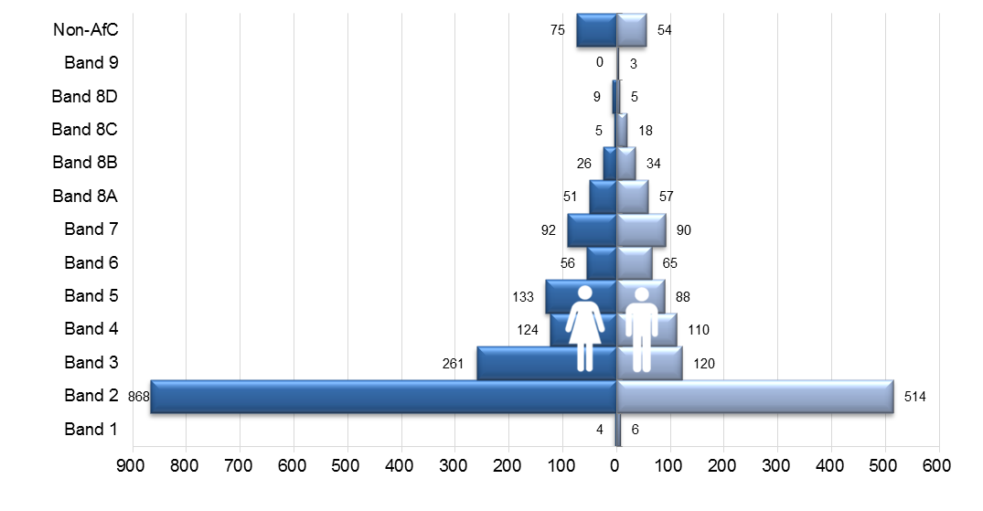

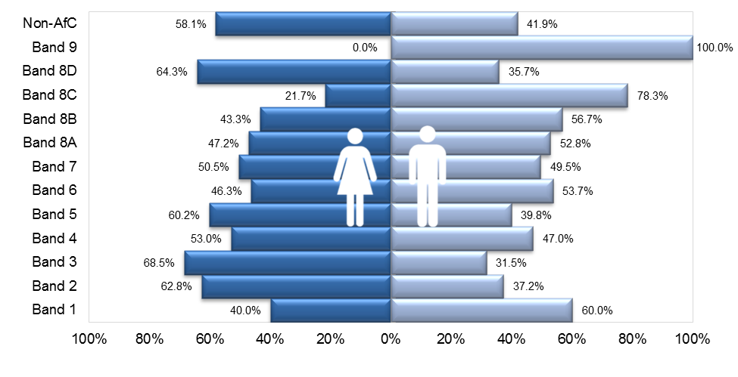
Percentage of men and women in each pay band
Hourly Rate by gender for each grade

The following graphs show the breakdown by mean and median hourly rates for each grade, by gender.

Mean Hourly rate for each grade

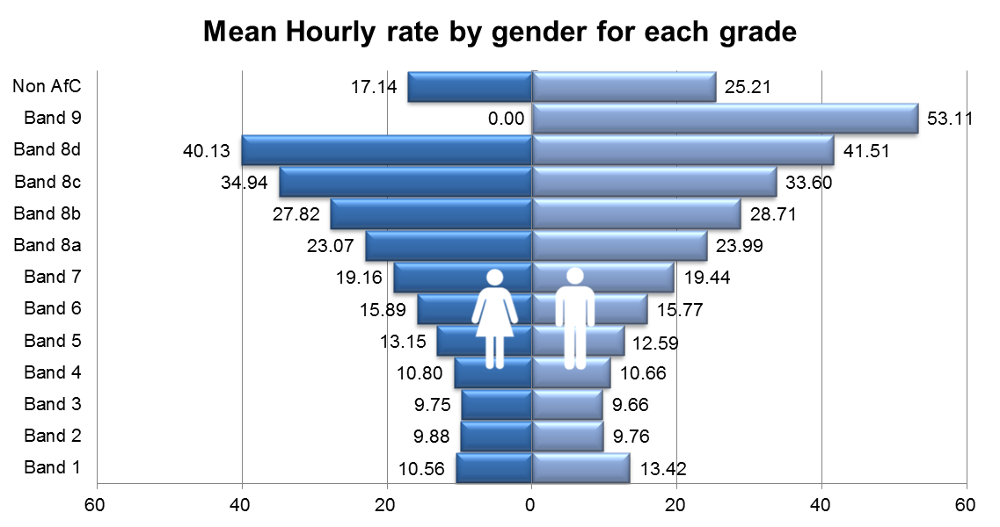

Median Hourly rate for each grade

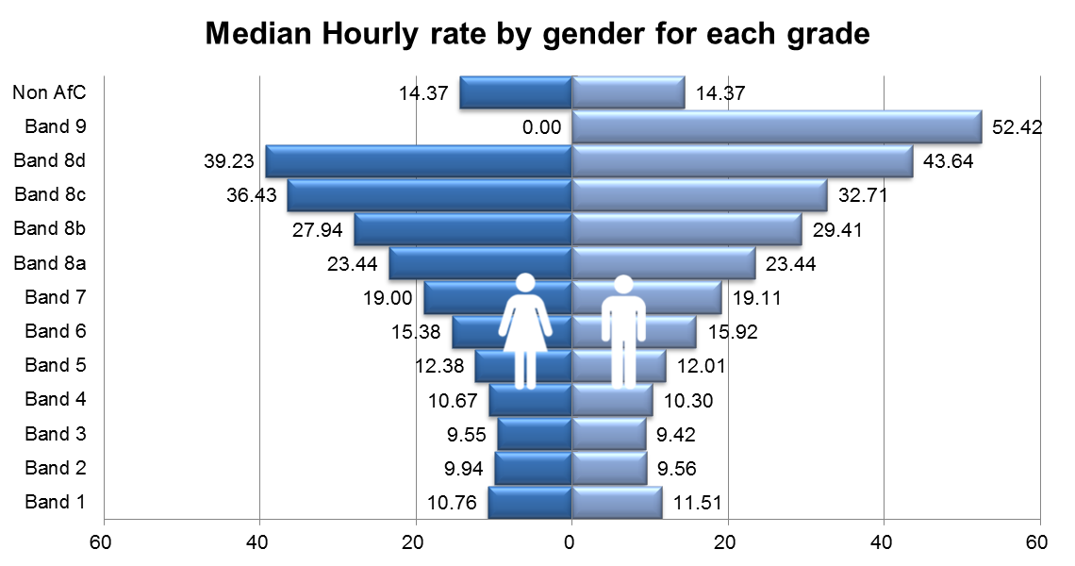
Mean and Median Pay Gap per Band

The charts below demonstrate the mean and median pay gap between men and women at each pay band. These reveal that some of the larger pay gaps are at the bands where there is a small head count, but are all or mostly of one gender, for example there are only three colleagues within Band 9, however they are all men, so the mean and median pay gaps for Band 9 are both 100%.

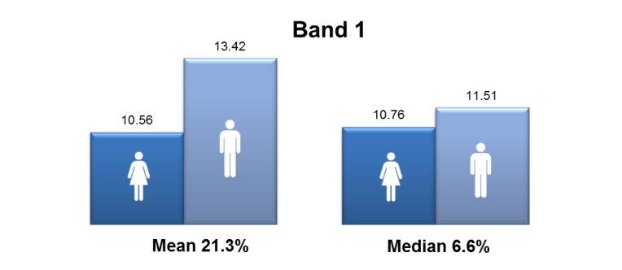

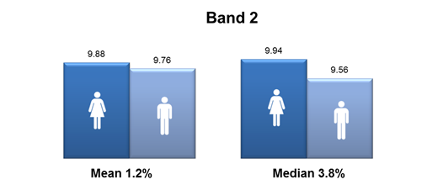

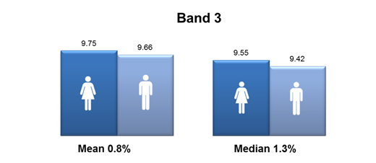

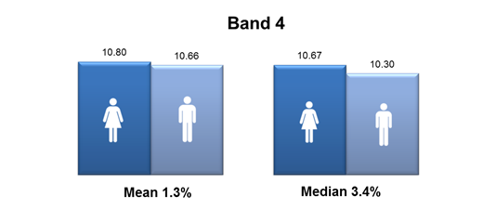

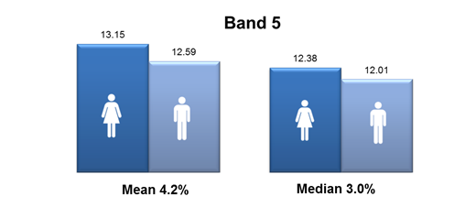

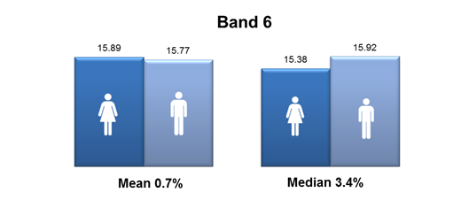

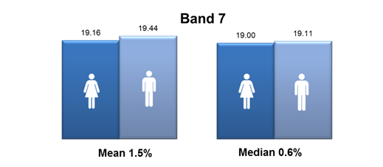

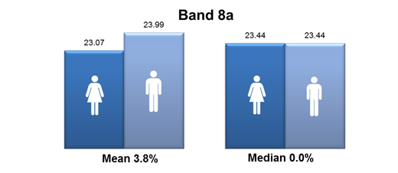

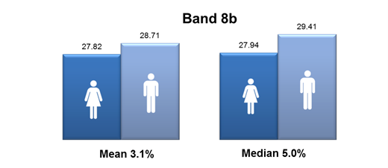

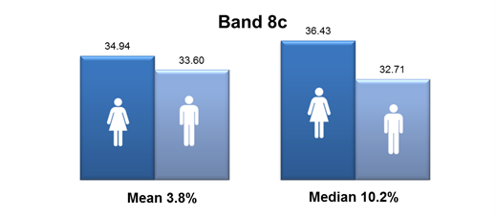

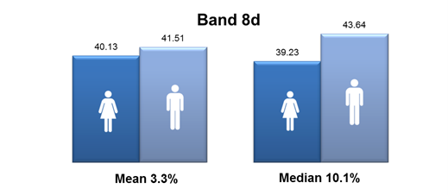

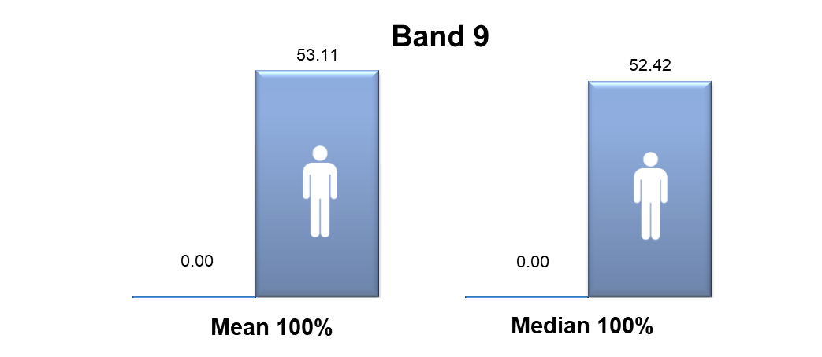

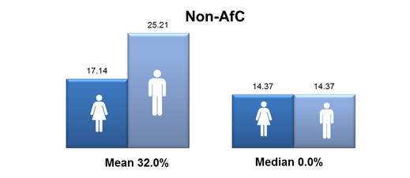

Proportion of males and females in each pay quartile

The graph below illustrates the gender distribution of the workforce across four equally sized quartiles. The proportion of males and females in each quartile, from the lowest to the highest paid, is calculated by dividing the workforce into four equal parts. It can be seen that the first three quartiles contain a significantly higher percentage of women than men and it is positive to note that there has been an improvement from the previous year in the gender balance of the upper quartile, with 52.3% women, compared to 50.4% last year and 48.4% in 2016-17.

2018-19 quartiles

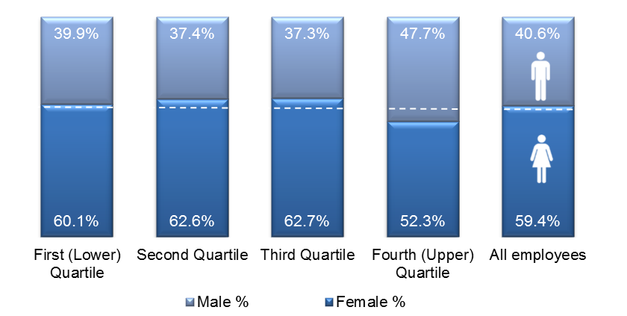
Lowest ← Pay → Highest

2017-18 quartiles
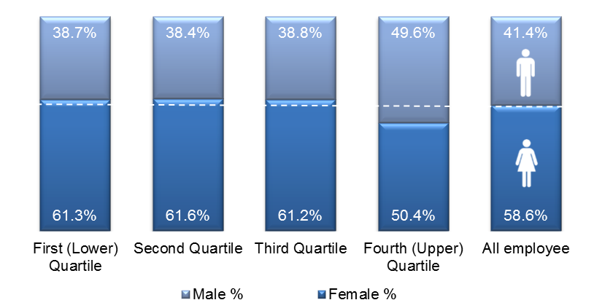

Lowest ← Pay → Highest

Gender pay gap in hourly pay

Mean gender pay gap in hourly pay

The mean, or the average, is calculated by adding up the wages of all colleagues and dividing the figure by the total number of employees. The mean gender pay gap is then the difference between mean male pay and mean female pay. The mean gender pay gap for hourly pay within the NHSBSA in 2018-19 is 11.9%. This difference in hourly pay is influenced by the greater proportion of women in the lower pay bands. It is encouraging to note that this gap has reduced from 2017-18 by 2.2%, and from 15.4% in 2016-17.

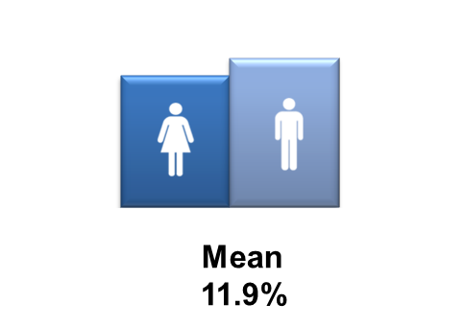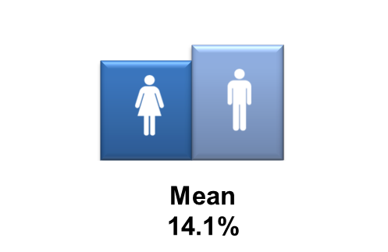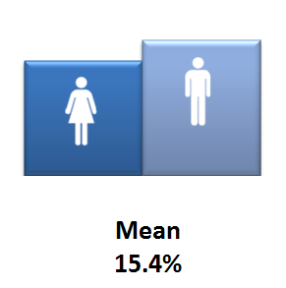
2018-19 2017-18 2016-17

Median gender pay gap in hourly pay

The median is the figure that falls in the middle of a range when the wages of all employees are lined up from the lowest to the highest salary. The median gap is the difference between the employee in the middle of the range of male wages and the middle employee in the range of female wages.

In 2018-19 there is a 0.8% median gender pay gap between men and women in the NHSBSA, compared to 3.1% in 2017-18 and 0% in 2016-17, which was very unusual statistically.
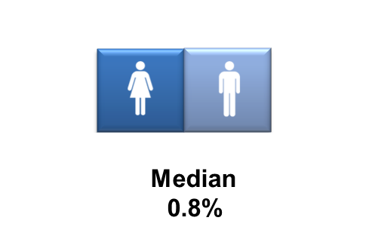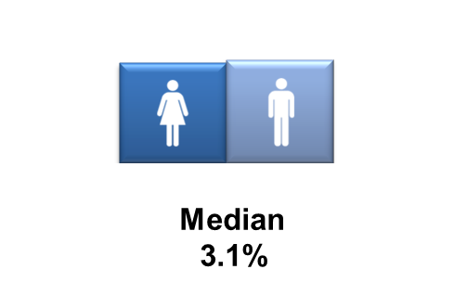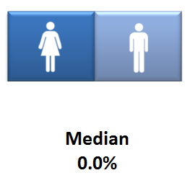
2018-19 2017-18 2016-17

Bonus gender pay gap

The NHSBSA has a performance related bonus paid in only one area of the organisation (NHS Prescription Services) where the bonus is paid for high volume data entry depending on output and accuracy, regardless of gender. The staff roles that qualify for the bonus are in pay bands at the lower end of the pay scale.

Proportion of males and females receiving a bonus payment

More female staff than men received a bonus in 2018-19, with 27.7% of total female staff, compared to 22.7% of all male staff receiving a bonus. This was influenced by the greater proportion of female staff in the roles which qualify for the bonus. It is interesting to note that the overall amount of all employees receiving a bonus has reduced from the previous year.
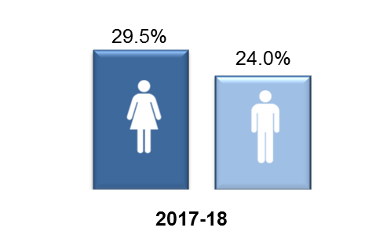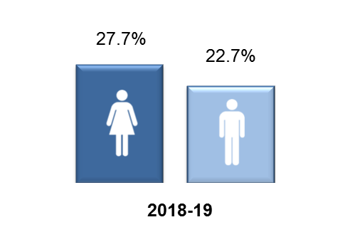

Mean and median bonus gender pay gap

The chart below reveals that there is a 15.4% pay gap between the mean bonus pay of the male and female staff who received the above bonus in the year 2018-19, and a 17.9% bonus pay gap using the median calculation. Interestingly this shows that although more women than men received a bonus, on average men received a higher bonus amount, which would be linked to achieving higher rates of output and accuracy. Both the median and mean bonus pay gaps have increased from 2017-18; by 5.5% and 0.7% respectively.

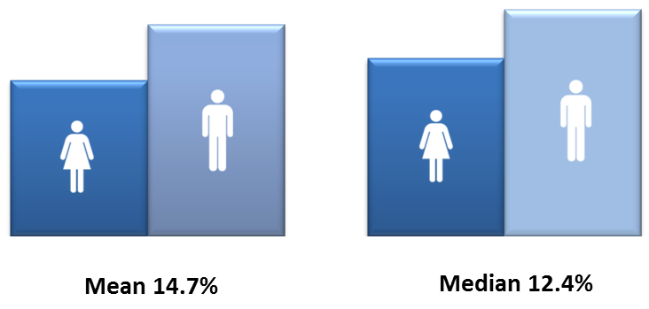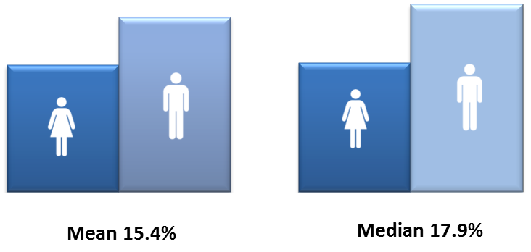
2017-18 2018-19

The above bonus scheme is currently in the process of being phased out which will mean that there will be no bonus payments made within the NHSBSA after that point.

Summary

The table below summarises the various gender pay gap calculations for 2018-19 and includes those for 2017-18, for comparison purposes. In 2018-19 there is a 0.8% median gender pay gap between men and women in the NHSBSA, and it is positive to note that this has reduced by 2.3% from the previous year.

The mean gender pay gap for hourly pay is 11.9%. This difference in hourly pay is influenced by the greater proportion of female staff occupying more roles in the lower pay bands. It is encouraging to note that this has also reduced from 2017-18, by 2.2%.

There was a 15.4% pay gap between the mean bonus pay of the male and female staff who received a bonus in the year 2018-19, and a 17.9% bonus pay gap using the median calculation. However, the bonus scheme is currently in the process of being phased out which will mean that there will be no bonus payments made within the NHSBSA after that point

 |  |  | % 2017-18 | % 2018-19 | % change
Median gender pay gap |  |  | 3.1% | 0.8% | - 2.3%
Mean gender pay gap |  |  | 14.1% | 11.9% | - 2.2%
Median bonus gender pay gap |  |  | 12.4% | 17.9% | + 5.5%
Mean bonus gender pay gap |  |  | 14.7% | 15.4% | + 0.7%
Proportion of male and female employees paid a bonus: |  | Male | 24.0% | 22.7% | - 1.3%
 |  | Female | 29.5% | 27.7% | - 1.8%
Proportion of male and female employees in each quartile:
 | 2017-18 |  |  | 2018-19
Quartile | Female % |  | Male % | Female % | Male %
First (lower) quartile | 61% |  | 39% | 60% | 40%
Second quartile | 62% |  | 38% | 63% | 37%
Third quartile | 61% |  | 39% | 63% | 37%
Fourth (upper) quartile | 50% |  | 50% | 52% | 48%

Actions to remove the gender pay gap

The NHSBSA is committed to addressing our gender pay gap and is undertaking a wide range of actions to reduce this. During the last year, significant progress has been made in the following areas:

- Gathering further insight to understand the experiences of women working in the NHSBSA through holding focus groups for female colleagues, with attendees identifying two key priority areas for action; a network and a development offer, both specifically in-house and for women in the NHSBSA
- Creation of our new Shadow Board as part of our leadership development offer. The Shadow Board will meet the day before each main Board to debate, provide constructive challenge and feedback on Board agenda items. This initiative helps us to develop our aspiring future leaders and provides an opportunity for us to proactively address the under-representation of some equality groups at senior levels within the NHSBSA, including women
- Development of our Women’s Colleague Network, as identified as a priority by the above focus groups. Aimed at increasing the voice of female colleagues, it will feed into the wider Diversity and Inclusion Network, with a link to the above Shadow Board, and will focus on issues specific to women. Through their lived experience, network members will act as a ‘critical friend’ to help identify any issues or barriers in relation to NHSBSA practices and policies to ensure they’re as inclusive as possible. Membership will be open to any interested female colleagues, regardless of role or pay band, and will also provide learning and development opportunities as well as networking and support.
- Progression of a Women in Leadership development programme aimed specifically at female staff with potential, based on the outputs of the above focus groups, to help develop skills and confidence to progress. Members of the Learning and Organisation Development team have now been accredited by Springboard through completion of their ‘Train the Trainer’ programme and are currently finalising the bespoke elements for the NHSBSA, with a pilot planned for the spring
- Delivering communications campaigns for staff and externally, such as those for International Women’s Day, which raise awareness of female role models working at a senior level within the NHSBSA or in a traditionally male-dominated occupation.
- Supporting all staff to develop their careers and reach their potential through our enhanced appraisal and personal development planning process, as well as promotion of learning and development opportunities such as external Women in Leadership events.
- Raising awareness amongst managers to support them to hold career conversations with their team members, to help our people to reach their potential.
- Reviewing our external and internal recruitment and selection processes, to ensure they support fairness and equality in all our recruitment, and extending our candidate reach by utilising social media and other recruitment platforms to attract a wider and more diverse range of applicants.

Going forward, in 2020-21 we will focus on:

- Supporting the new Shadow Board which launches in April 2020, and ensuring that all members have sponsorship from a Leadership Team member to support their career development and aspirations

- Development of the new Women’s Network which launched in March 2020, empowering and supporting them to work on areas they identify for action

- Launch of the in-house Women in Leadership development programme, following the pilot which will take place in the spring

- Developing and retaining our people with potential and also attracting external talent as part of our talent management strategy, linked to our enhanced appraisal and PDP process, and working collaboratively with the NHS Leadership Academy and others on talent programmes

- As part of a wider work stream on recruitment and on-boarding, identifying and removing any gender bias, including unconscious bias, in the selection methods we use, and ensure the recruitment process is returner-friendly. We will ensure that interviewers have undergone recruitment training including understanding of bias and the importance of only using structured interviews and standard assessment criteria. We will also increase the use of skill-based assessment tasks in recruitment as a more effective measure of suitability for a role than interview

- Developing specific guidance for carers and their managers, to ensure that all colleagues with caring responsibilities know how to access the options available

- Developing guidance on supporting colleagues with menopause in the workplace as this can have a detrimental impact on the career development of women, and training ‘menopause champions’ who can provide support to colleagues

- Reviewing our family-friendly HR policies, developing supporting guidance for colleagues and managers, increasing awareness of these through promotional campaigns for colleagues, and monitoring uptake to measure their impact

- Encouraging flexible working to be considered for all new vacancies, at every level of the organisation, and that colleagues and managers understand the benefits of flexible working, to ensure that all our people, irrespective of gender, have the opportunity to work in a way that supports their career aspirations and home life balance.

