**ePACT2 User Guide**

Reconciling Your Invoice

Prior to April 2015

|  |
| --- |
| Contents  [Accessing the Systems Required 1](#_Toc520387728)  [Invoice Received 1](#_Toc520387729)  [Finding the IPP and Remuneration Reports 3](#_Toc520387730)  [Using the Itemised Prescribing Report (IPP) 5](#_Toc520387731)  [Comm. /Prov. Overview 6](#_Toc520387732)  [Comm. / Prov. Individual 7](#_Toc520387733)  [Using the Remuneration Reports 8](#_Toc520387734)  [Remuneration Values 8](#_Toc520387735)  [Summary 8](#_Toc520387736)  [Itemised Listing 10](#_Toc520387737)  [Practice Level 11](#_Toc520387738)  [Common Queries 13](#_Toc520387739)  [Getting Help 14](#_Toc520387740) |

# Accessing the Systems Required

To reconcile your invoice you will need access to the Itemised Prescribing Payment (IPP) Report and the Remuneration Report, both of which are located within ePACT2.

Access to this system is via a registration process. Details on how to register for access can be found at <https://www.nhsbsa.nhs.uk/epact2>

If you wish to see the individual drugs which have been prescribed this information can also be accessed via ePACT2.

A standard report (Invoice Reconciliation Report) is available via ePACT2 which will provide a breakdown of the prescribing costs attributed to an organisation at unit/cost centre level. A guide to accessing this report is available at <https://www.nhsbsa.nhs.uk/epact2/epact2-user-guides>

# Invoice Received

**Hospital Unit Invoice**

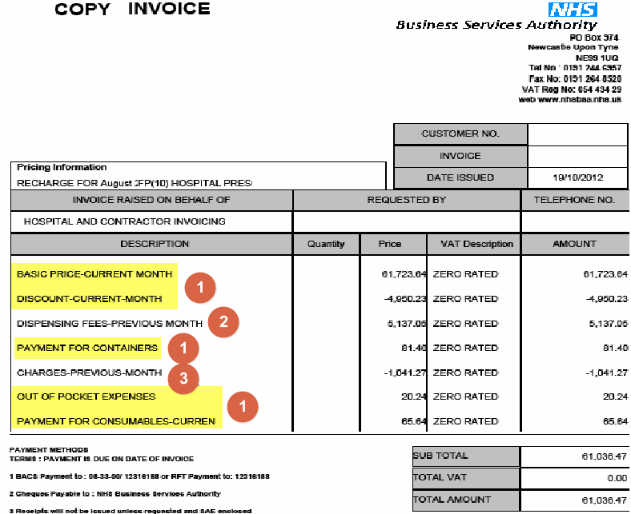

**Provider Cost Centre Invoice**

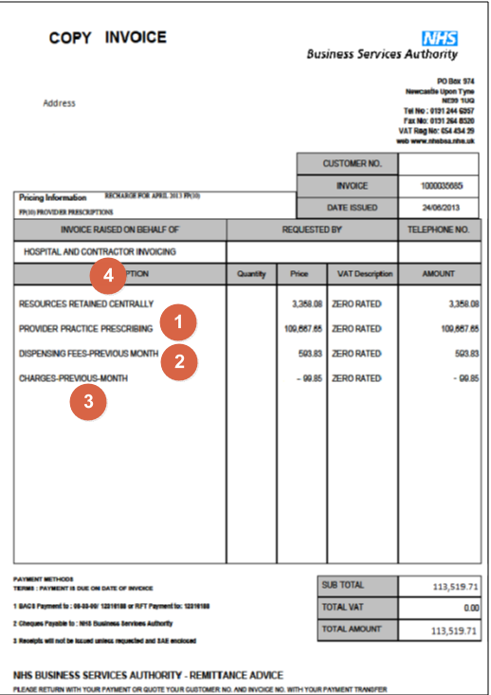

1. These elements make up the ‘Actual Cost’ of prescribing and can be reconciled to the prescribing costs shown within the IPP report. ePACT2 can be used to split the ‘Actual Cost’ to the individual cost centres/units under the organisation.

2. Shows the ‘Dispensing Fees - Previous Month’ and can be reconciled using the Remuneration Report.

3. Shows the ‘Charges - Previous Month’ and can be reconciled using the Remuneration Report.

4. Shows the ‘Resources Retained Centrally’ attributed to the organisation and can be reconciled using the IPP report. Prior to April 2015 this cost only appears on provider cost centre invoices and will not appear on a Hospital Trust Invoice.

If your organisation is a Hospital Trust with provider cost centres registered under it both invoices will be received.

The guidance included in the guide will allow the user to reconcile the total cost shown on both invoices combined.

# Finding the IPP and Remuneration Reports

Log-in to ePACT2 using the user ID registered for the system and your password associated with the user ID.

Once you have signed in the system ‘Home’ page will be displayed.

The Financial Management Reports are located within the Dashboards area of ePACT2. To access the Dashboard list:

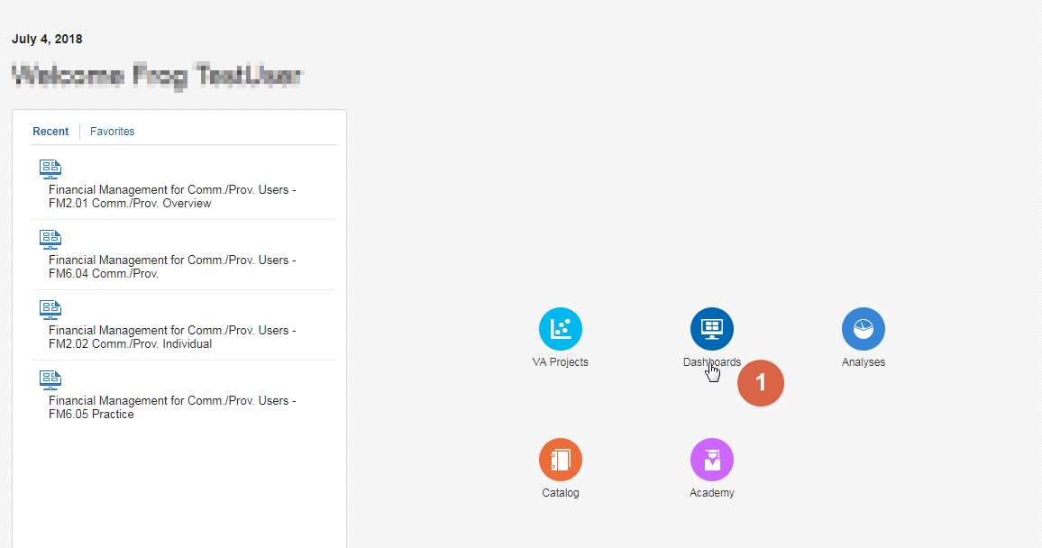

1. From the system ‘Home’ page select the Dashboards icon.
2. Select the link for ‘Finance Management for Comm./Prov. Users from the list available.

|  |  |
| --- | --- |
| Description: Z:\Images\Bev\info_button.png | Area Team users the link will say ‘Finance Management for Area Users’ |

1. It may be necessary to scroll through the list of dashboards available to view the link for ‘Finance Management’.

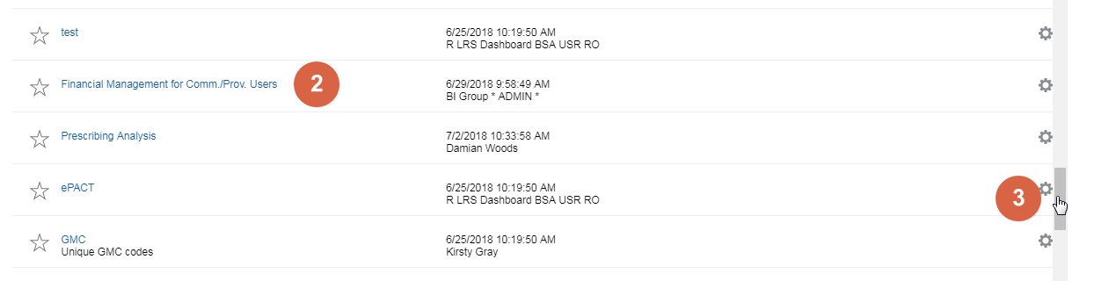

The ‘Finance Management’ dashboard will open:

The report page will be displayed as:

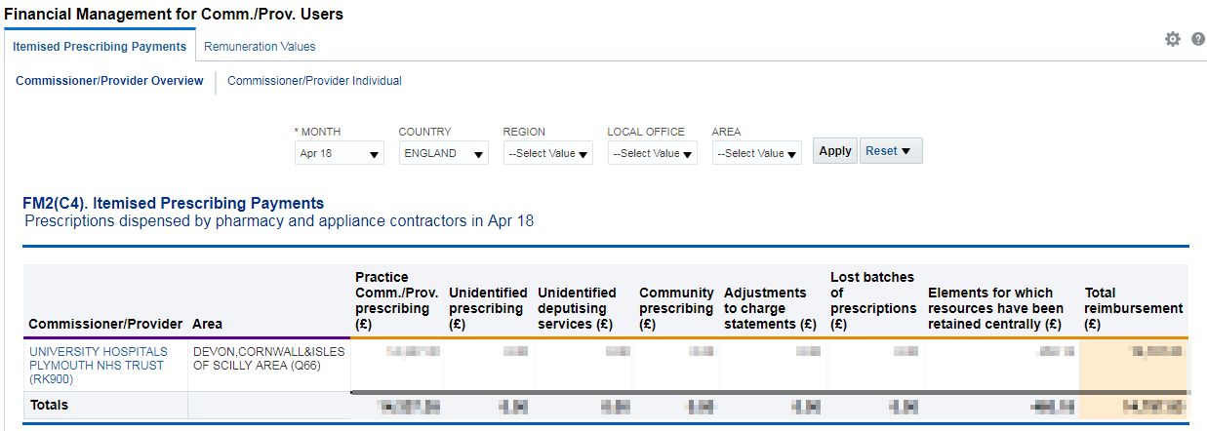

# Using the Itemised Prescribing Report (IPP)

The Itemised Prescribing Report tab will be opened by default.

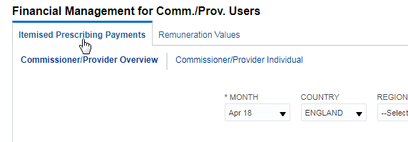

The IPP reports are split into 2 sections:

1. Comm./Prov. Overview – which is an overview of all organisations that the user has access rights to view
2. Comm./Prov. Individual – shows individual reports for each organisation

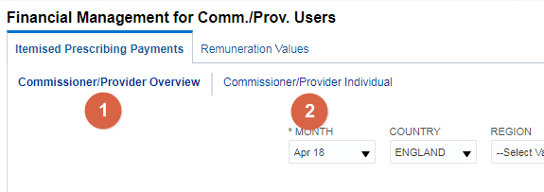

## Comm. /Prov. Overview

Within the Comm. /Prov. Overview report a selection of prompts will allow the user to change or limit the data displayed within the Overview.

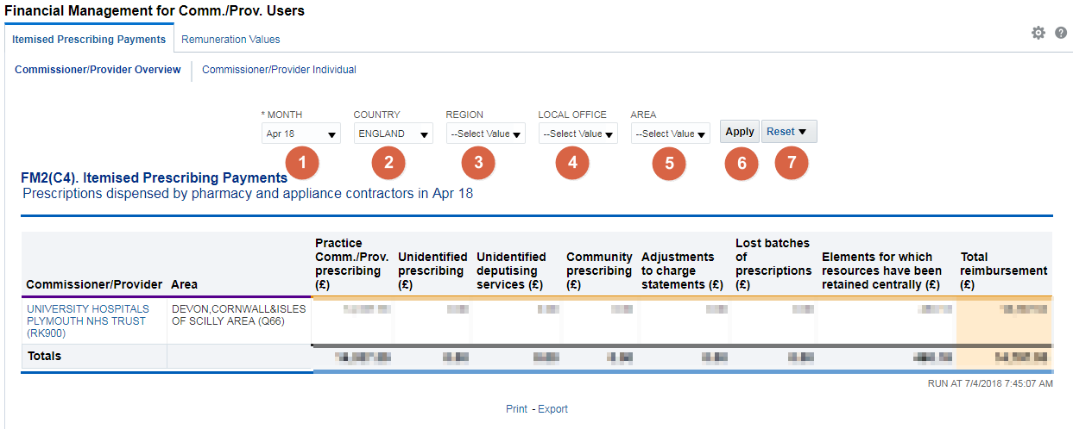

1. Month – Allows the user to select the time period the wish to view data for. Data will be available from April 2018 onwards, if a time period earlier than this is selected the report will return a message of ‘No Results’.
2. Country – Allows the user to limit information to a selected Country, data is only available for ‘England’.
3. Region – Allows the user to limit information to a selected Region. If a Region is selected which the user does not have access rights to the system will return a message of ‘No Results’.
4. Local Office - Allows the user to limit information to a selected Local Office. If a Local Office is selected which the user does not have access rights to the system will return a message of ‘No Results’.
5. Area - Allows the user to limit information to a selected Area. If an Area is selected which the user does not have access rights to the system will return a message of ‘No Results’.
6. Apply – Confirms the selections made and regenerates the report to display the selected information.
7. Reset – Will reset any selections made to the default settings.

## Comm. / Prov. Individual

A selection of prompts will be displayed within the report to allow the user to select the report required.

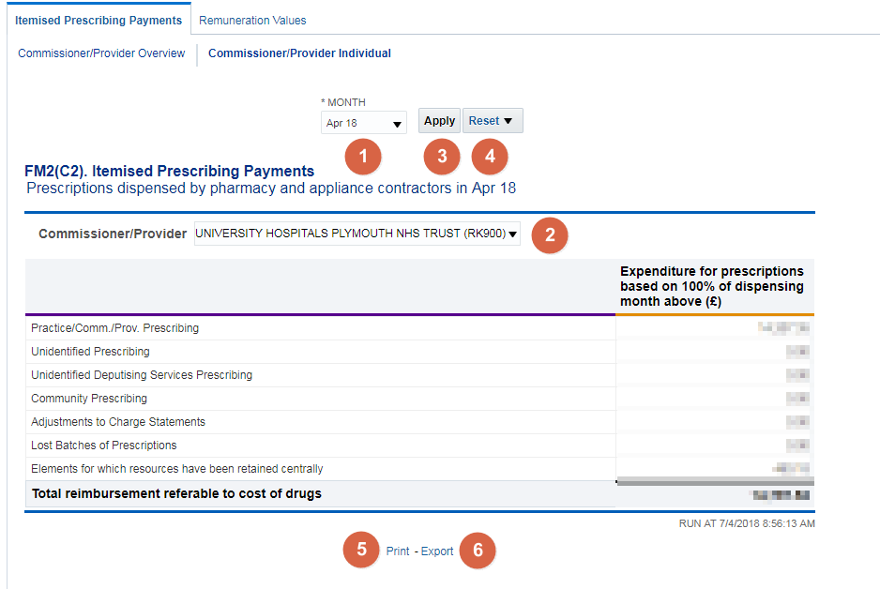

1. Month - Allows the user to select the time period the wish to view data for.

|  |  |
| --- | --- |
| Description: Z:\Images\Bev\info_button.png | Data will be available from April 2018 onwards, if a time period earlier than this is selected the report will return a message of ‘No Results’. |

1. Commissioner/Provider – Allows the user to select the organisation they wish to view the report for. Only those organisations the user has access rights to view data for will be displayed within the drop down list.
2. Apply – Confirms the selections made and regenerates the report to display the selected information.
3. Reset – Will reset any selections made to the default settings.
4. Print – Will display the available formats the report can printed in.
5. Export – Will display the available formats the report can be exported in.

# Using the Remuneration Reports

Commissioner / Providers Users will have access to Remuneration Values Reports which can be accessed by choosing the Remuneration Values tab within the Financial Management dashboard:

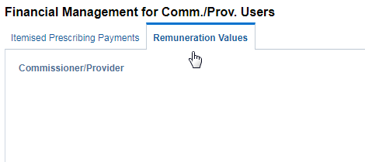

## Remuneration Values

Remuneration Recharges report will show:

* A summary for a dispensing month
* An itemised listing for a dispensing month

### Summary

A selection of prompts will be displayed within the report to allow the user to select the report required.

Total ‘Prescription Charge’ and ‘Remuneration’ figures will be displayed for each organisation. The summary report showing all organisations under the selected organisation can be downloaded in a single file.

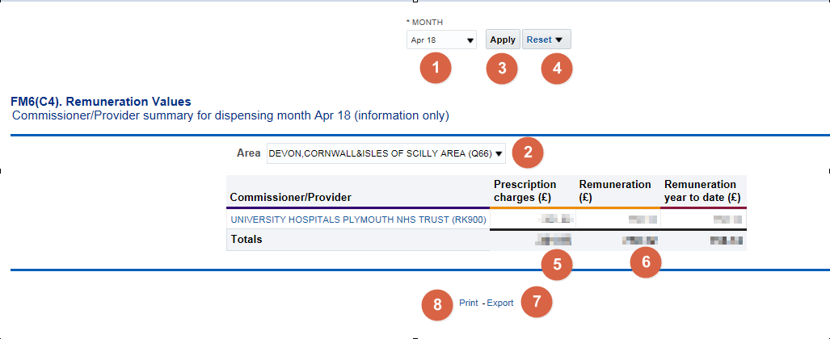

1. Month - Allows the user to select the time period the wish to view data for.
2. Area – Allows the user to select the Area they wish to view the report for. Only those organisations the user has access rights to view data for will be displayed within the drop down list.
3. Apply – Confirms the selections made and regenerates the report to display the selected information.
4. Reset – Will reset any selections made to the default settings.
5. The total ‘Prescription Charges’ attributed to the organisation for the time period selected will be displayed within the summary, this can be used to reconcile the invoice received.
6. The total ‘Remuneration’ attributed to the organisation for the time period selected will be displayed within the summary; this can be used to reconcile the invoice received.
7. Print – Will display the available formats the report can printed in.
8. Export – Will display the available formats the report can be exported in.

### Itemised Listing

The prompts for ‘MONTH’ and ‘Area’ from the Summary report apply changes to the itemised report also.

There are two additional prompts on the Itemised report to allow you to change the ‘Area’ and ‘Commissioner/Provider’

Month - Allows the user to select the time period the wish to view data for.

Apply – Confirms the selections made and regenerates the report to display the selected information.

Reset – Will reset any selections made to the default settings.

Print – Will display the available formats the report can printed in.

Export – Will display the available formats the report can be exported in.

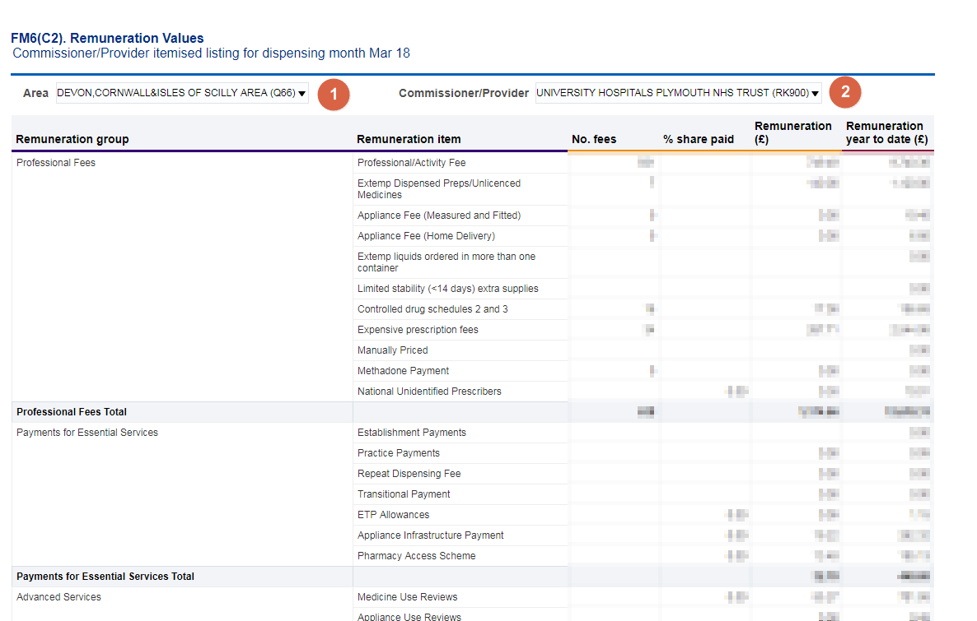

1. Area – Allows the user to select to view/export the itemised report for all organisations or a single organisation.

|  |  |
| --- | --- |
| Description: Z:\Images\Bev\info_button.png | The prompt will default to ‘All’, to view the report for a single organisation the parent organisation name should be selected. An additional prompt will then be displayed to allow the user to select the organisation required. |

1. Commissioner/Provider – Allows the user to select the organisation they wish to view the report for. Only those organisations the user has access rights to view data for will be displayed within the drop down list.

|  |  |
| --- | --- |
| Description: Z:\Images\Bev\info_button.png | The prompt will only be shown when a value other than ‘All’ is selected in the ‘Area’ prompt. |

### Practice Level

To view the Remuneration Values summary and itemised report down to unit or cost centre level, select the blue hyperlink available in the Remuneration Values summary table

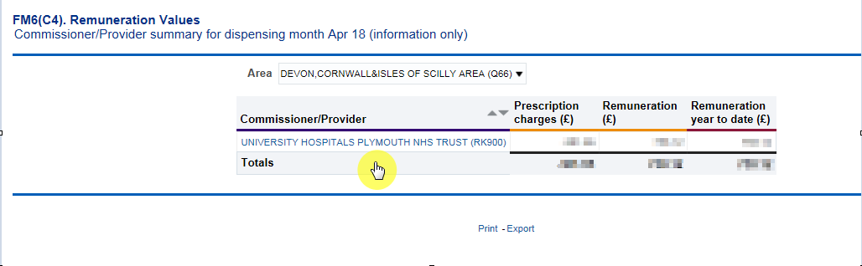

A Practice summary and Practice itemised listing will be displayed:

**Practice Summary:**

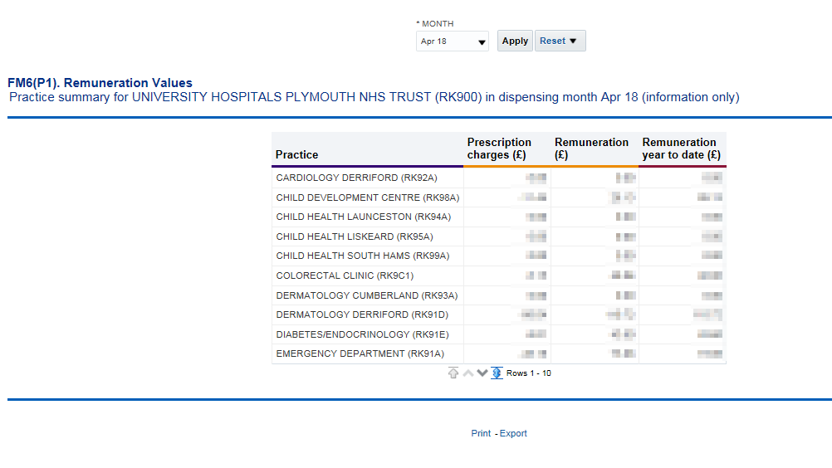

|  |  |
| --- | --- |
| Description: Z:\Images\Bev\info_button.png | The ‘Prescription Charges’ and ‘Remuneration’ totals for all practices will be displayed in the summary and can be exported in a single file. |

The report lists the first ten practices/ cost centres within the organisation, to view all practices/ cost centres for the selected organisation click on the ‘display maximum rows’ icon cid:image005.jpg@01D41E81.4742C680

**Practice Itemised Listing:**

Allows the user to view/export the Itemised Remuneration report for all practices or a selected practice registered under the organisation.

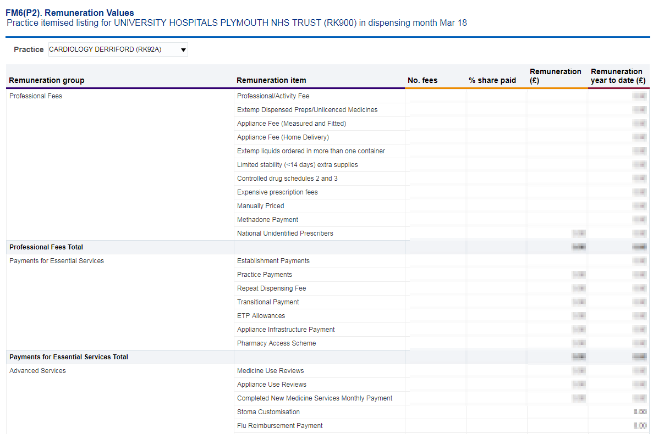

A selection of prompts will be displayed within the report to allow the user to select the report required.

Month - Allows the user to select the time period the wish to view data for.

Practice – Allows the user to select the practice they wish to view the report for. Only those organisations the user has access rights to view data for will be displayed within the drop down list.

|  |  |
| --- | --- |
| Description: Z:\Images\Bev\info_button.png | The prompt will default to ‘All’, to view/export the report for a single practice the practice should be selected from the drop down list. |

Apply – Confirms the selections made and regenerates the report to display the selected information.

Reset – Will reset any selections made to the default settings.

Print – Will display the available formats the report can printed in.

Export – Will display the available formats the report can be exported in.

# Common Queries

|  |  |
| --- | --- |
|  | **The dispensing fees and patient charges shown on the invoice do not reconcile with the Remuneration Report.** |

Check that you are using the Remuneration Report for the correct month. Dispensing fees and patient charges shown on the invoice relate to the previous months Remuneration Report. Therefore the invoice for July’s prescriptions will reconcile with June’s Remuneration Report.

|  |  |
| --- | --- |
|  | **Charges are shown on the Itemised Remuneration Report for Appliance Infrastructure Payments but the provider has not prescribed** **any appliances on an FP10 Prescription.** |

Appliance Infrastructure payments are made to appliance contractors in the same way Establishment payments are paid to pharmacy contractors. The cost of these payments are apportioned across all Primary Care Organisations (PCOs) and Trusts. The calculation used to apportion the cost is shown in the glossary at <http://www.nhsbsa.nhs.uk/PrescriptionServices/3234.aspx>

|  |  |
| --- | --- |
|  | **I cannot access ePACT2.** |

If you do not have an ePACT username or password, please complete the registration process, registration guidance is available at instructions at <https://www.nhsbsa.nhs.uk/epact2>. If you have any further queries regarding the system please contact Information Services at [nhsbsa.help@nhs.net](mailto:nhsbsa.help@nhs.net) or 0191 2035050.

|  |  |
| --- | --- |
|  | **I cannot get the dispensing fees on the Remuneration Report to match the figure on the invoice using the guidance provided. The figure is out by a small** **amount (i.e. pence).** |

This is due to slight differences in the way figures are rounded in the Remuneration Report totals

|  |  |
| --- | --- |
|  | **When using ePACT2 to split costs between each hospital unit, the total prescribing figure does not add up to the amount invoiced.** |

The hospital invoice is now based on Actual Cost. When using ePACT to split costs between hospital units the actual cost field should be used. Additionally, prescriptions that have been dispensed by a GP practice should be excluded from the data as these will have been charged to the CCG of the GP practice. To establish where a prescription has been dispensed the dispenser code field should be included in the report.

A standard report template is available within ePACT2 providing prescribing cost split by hospital unit/cost centre. A guide to accessing the template, ‘Accessing the Invoice Reconciliation Report’, is available via the ePACT2 User Guide webpage at <https://www.nhsbsa.nhs.uk/epact2/epact2-user-guides>.

# Getting Help



**Additional training material and user guides**

The NHSBSA has developed a number of how to guides to help you get the best out of ePACT2. These can be found at: [Additional User Guides](https://www.nhsbsa.nhs.uk/epact2/epact2-user-guides)

**WebEx sessions**

WebEx will be provided on a number of different topics and features. More information about these can be found here: [WebEx Training](https://www.nhsbsa.nhs.uk/epact2/epact2-training)