Information Services Portal
Login/Logout
(Registered User)

Contents Page

- Login
- Footer
- How to Register
- Forgotten Password
- Account Locked
- Logout
- Other Information

LOGIN PAGE

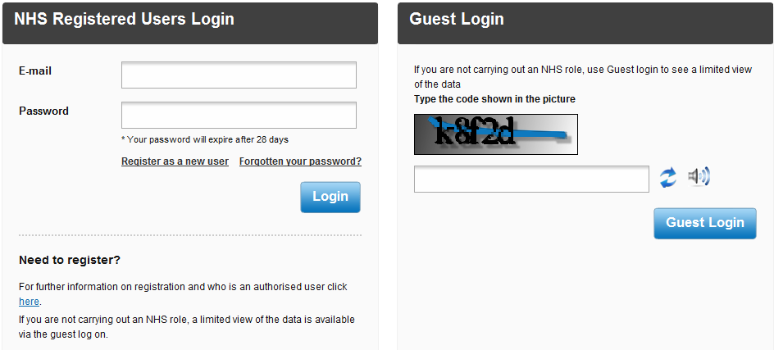
Login
1a
1b
1a
From the ISP login page, enter your email address and password in the spaces provided.
1b
Click the Login button. Once you have successfully logged into the system you will be presented with the following page;
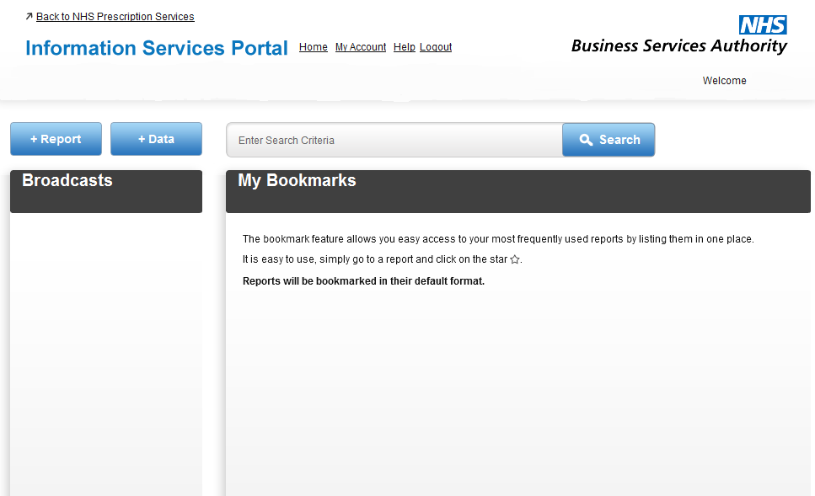
2d
2c
2b
2a
2a
2d
Please see the Selecting and Viewing Reports and Data Download User Guides for information on viewing reports.
2b
Please see the Searching for Reports User Guide for information on how to search for reports.
2c
Important information and news about the portal will be displayed under Broadcasts.
2d
Bookmarked reports will appear here. Please see the Bookmarking a Report for more information on how to bookmark reports.

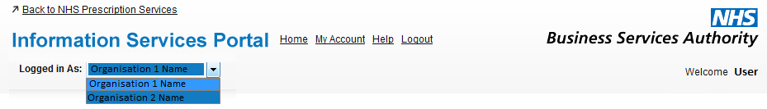

3e
3d
3c
3b
3a

3a
Select which organisation you wish to be logged on as. This box will only be available to users who have access to multiple organisations.
3b
Select to go back to the home page
3c
Select to go to your account. For more information, please see the My Account User Guide.
3d
Select to view user guides for the Information Services Portal.
3e
Select to logout of the system.

Footer

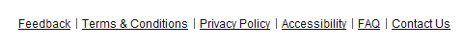

4f
4a
4b
4c
4d
4e

4a
A new page will open showing the Terms and Conditions.
4b
A new page will open showing privacy information.
4c
A new page will open showing accessibility information.
4d
A new page will open providing answers to Frequently Asked Questions.
4e
Click this link if you would like to contact us via email regarding any questions you have about the system.
4f
If you wish to give feedback about the Information Services Portal please select Feedback. The following page will open;
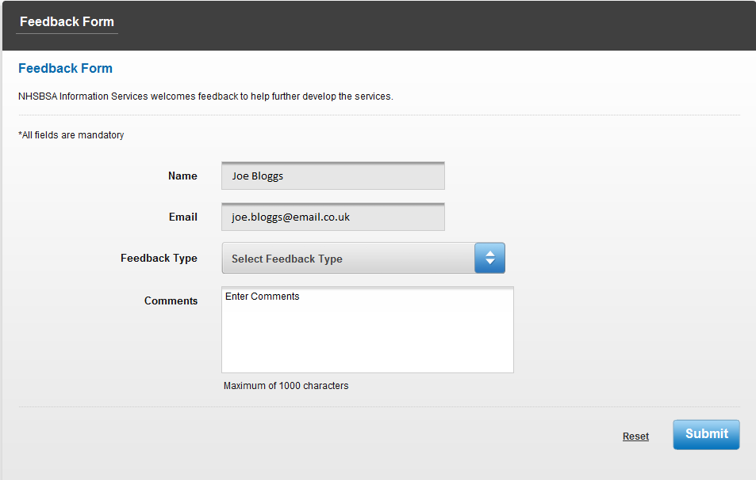
5a
5c
5b
5a
Your name and email address will be pre-populated.
5b
Select the type of feedback you wish to leave from the drop down box and leave your comments below.
5c
If you wish to remove the information you have entered, select Reset. When you have finished, select Submit to send your feedback. If your feedback has been sent successfully you will be sent to the following page;

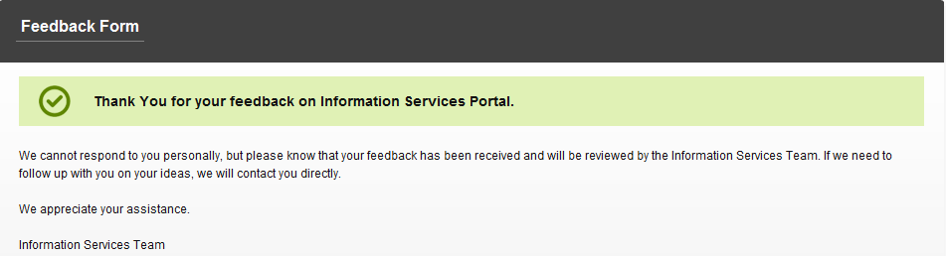

Login Page

How to Register
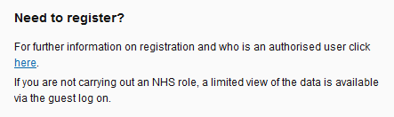
6a

6a
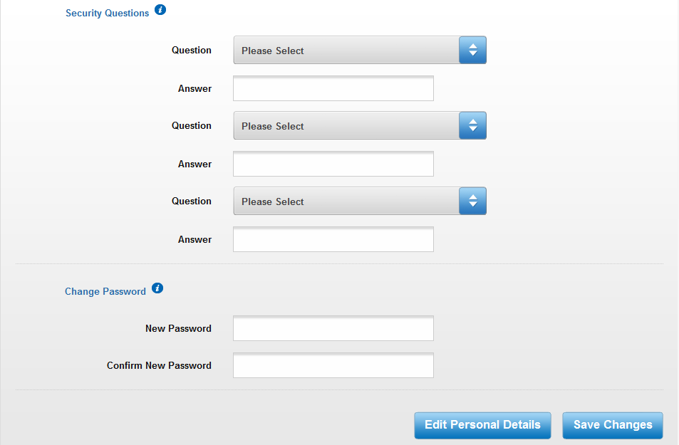
From the login page click on the link to open a new page with information on how to register for access to the Information Services Portal. If you are registering via the automated registration system, please see the Automated Registration User Guide. If you are registering by sending us a proforma, you will receive a link by email to continue setting up your account. The link will open the following page;
6e
6f
6c
6b
6d

6b
To set up your three security questions, choose a question from the drop down box and then enter your desired answer.
6c
Enter your desired password.
6d
For information on security questions and password, hover your mouse over the I symbol.
6e
Your personal details will be pre-populated, but if you wish to edit these details, select Edit Personal Details.
6f
Once you have finished, select Save Changes. You will be sent to the home page.

Forgotten Password
Login Page
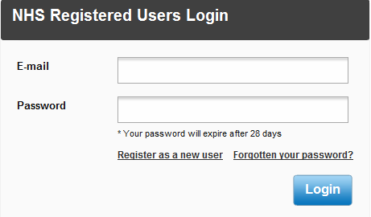
7a

7a
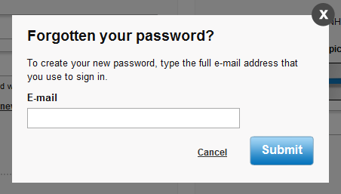
If you have forgotten your password, from the login page click Forgotten your password and the following will appear;

7b

7b
Enter your email address into the box and click Submit. The following box will appear;

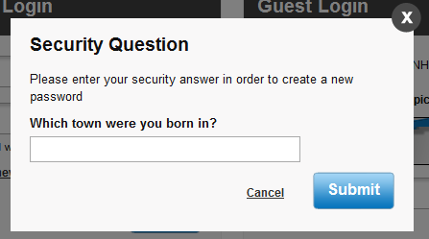

7c

7c
You will be asked one of your security questions. Enter your answer and click Submit. If successful the following message will appear;
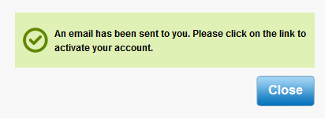

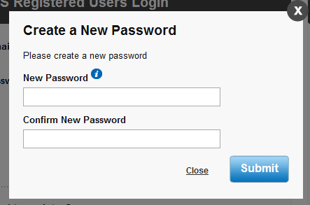
Once you have received the email, click on the link provided and answer the security question. Then the following will appear;
7e
7d

7d
Enter your new password and select Submit. You will then be directed to the home page.
7e
Hover your mouse over the I symbol for information on how to choose a password.

Account Locked
Login Page
8a
8a
If you enter the wrong password three times your account will become locked and this message will appear. To unlock your account click the link and the following will appear;
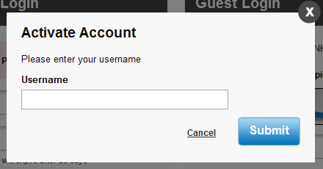

8b

8b
Enter your email address and click Submit. The following will appear;

8c

8c
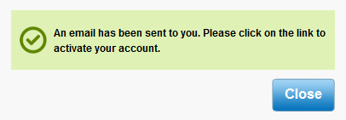
Answer the security question and select Submit. If successful the following will appear;

Once you have received the email, click on the link provided and answer the security question. Then the following will appear;

8e

8d

8d
Enter your new password and select Submit. You will then be directed to the home page.
8e
Hover your mouse over the I symbol for information on how to choose a password.

Logout
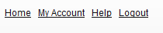
9a
9a
To logout of the system, click Logout. If you do not submit any requests for 30 minutes you will automatically be logged out of the system.

Other Information

- Your password will expire after 28 days. If you try to logon after your password has expired you will be directed to the change password screen where you have to enter a new password.

- If you do not logon for 12 months your access will expire and you will have to re-register.

