Information Services Portal
Login/Logout
(Guest User)

Contents Page

- Login
- Footer
- How to Register
- Logout

Login Page

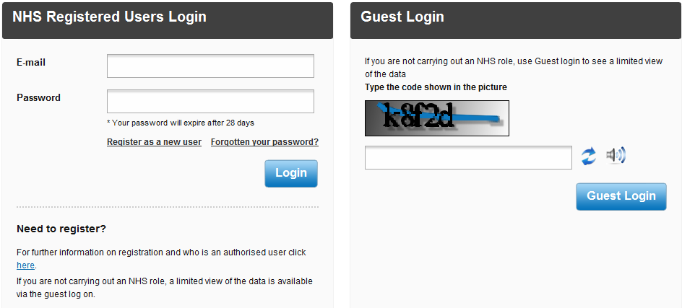
Login
1b
1a
1c
1a
To login as a guest user, go to the ISP login page and enter the code in the space provided.
1b
If you cannot read the code, you can either refresh the code to show a new code, or hear the code.
1c
Once you have entered the code, click Guest Login and you will be redirected to the home page.

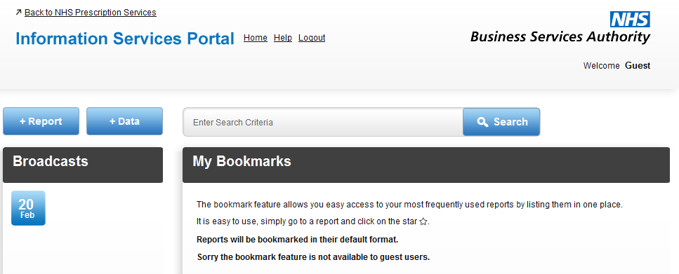

2d
2a
2c
2b
2a
For more information on how to view reports, please see the Selecting and Viewing Reports User Guide. For information on Data Download please see the Data Download User Guide.
2b
The bookmark facility is not available to guest users.
2c
Important news about the portal will be shown under Broadcasts.
2d
For more information on how to search for reports, please see the Searching for Reports User Guide.
3c
3a
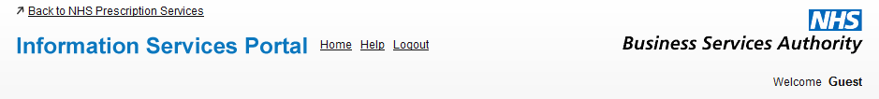
3b

3a
Select to return to the home page.
3b
Select to view user guides for the Information Services Portal.
3c
Select to logout of the system.

Footer
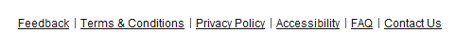

4f
4a
4b
4c
4d
4e

4a
A new page will open showing the Terms and Conditions.
4b
A new page will open showing privacy information.
4c
A new page will open showing accessibility information.
4d
A new page will open providing answers to Frequently Asked Questions.
4e
Click this link if you would like to contact us via email regarding any questions you have about the system.
4f
If you wish to give feedback about the Information Services Portal please select Feedback. The following page will open;
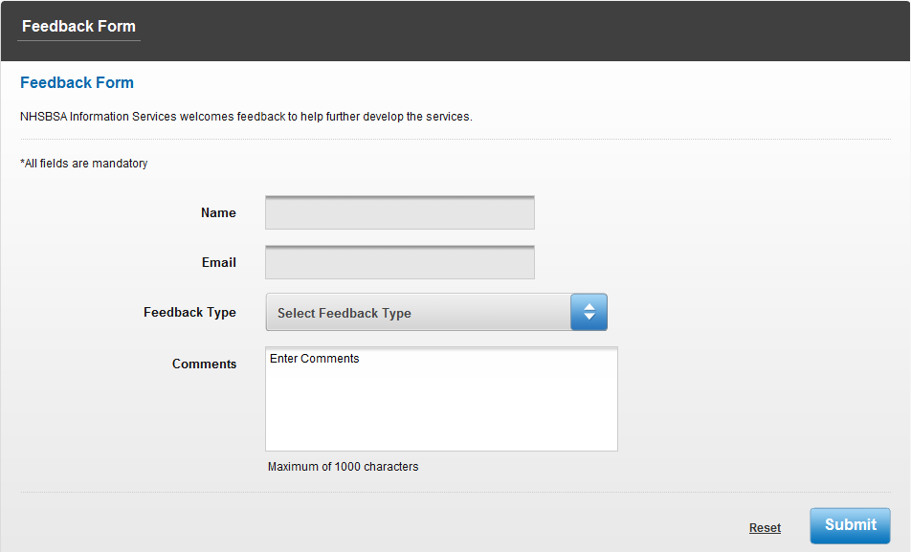
5a
5c
5b
5a
You will need to enter your name and email address in the spaces provided.
5b
Select the type of feedback you wish to leave from the drop down box and leave your comments below.
5c
If you wish to remove the information you have entered, select Reset. When you have finished, select Submit to send your feedback. If your feedback has been sent successfully you will be sent to the following page;

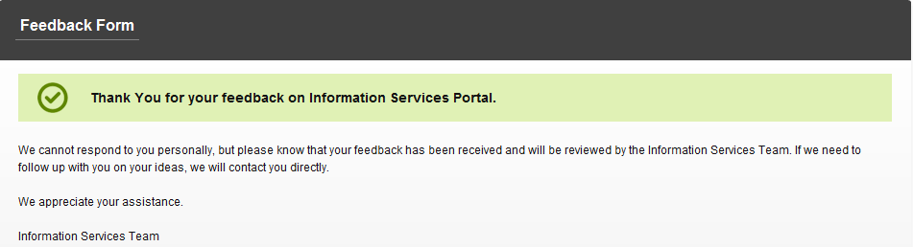

Login Page

How to Register
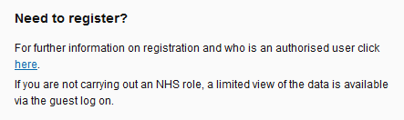

6a

6a
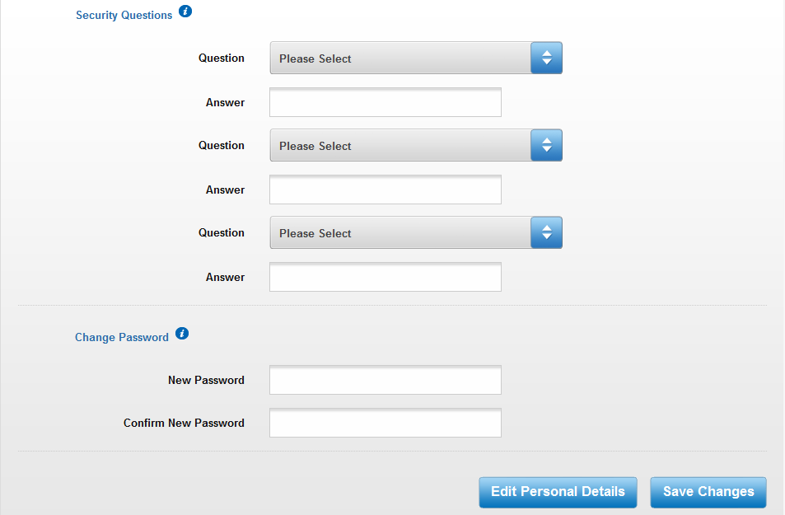
From the login page click on the link to open a new page with information on how to register for access to the Information Services Portal. If you are registering via the automated registration system, please see the Automated Registration User Guide. If you are registering by sending us a proforma, you will receive a link by email to continue setting up your account. The link will open the following page;
6b
6f
6e
6d
6c

6b
To set up your three security questions, choose a question from the drop down box and then enter your desired answer.
6c
Enter your desired password.
6d
For information on security questions and choosing a password, hover your mouse over the I symbol.
6e
Your personal details will be pre-populated, but if you wish to edit these details, select Edit Personal Details.
6f
Once you have finished, select Save Changes. You will be sent back to the login page.

Logout
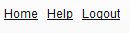
7a

7a
To logout of the system, click Logout. If you do not submit any requests for 30 minutes you will automatically be logged out of the system.

